

Faculty of Informatics and Computer Science

Software Engineering

AI-Driven Sports Injury Recovery Application

By: Moaz Mahmoud
Supervised By: Dr. Eng. Ahmed Fahmi

Abstract
Traditional physical therapy methods are not effective in ensuring patients and providers stay in touch when healthcare providers are away due to vacations, illnesses, or emergencies. Because of these disruptions, patients may have to wait longer for treatment, their rehabilitation may be uneven, and they are more likely to suffer from the same injury again. Moreover, patients often find it hard to read detailed medical images, which causes them to wrongly estimate the seriousness of their injuries and take inappropriate actions. A digital platform is developed that joins physical therapy practitioners and patients by introducing an application on mobile devices. The primary goals are to build an automated system for interpreting medical reports using machine learning, use AI to assess injuries and their severity, manage rehabilitation remotely, create AI-based injury prevention plans, and track exercises in real-time with computer vision technology. The software uses several layers that rely on machine learning, artificial intelligence, and computer vision. The module relies on well-tuned OCR to gather important information from diagnostic imaging reports. Classification of injuries is based on the accurate interpretation provided by OpenAI’s API. Healthcare providers can use role-based access control in the rehabilitation system to set and supervise individual patient protocols. Injury prevention relies on deep neural networks that analyze patients’ information to design unique plans for each person. MediaPipe pose estimation is used in real time to provide instant feedback during exercise. The system has a separate user interface for patients and providers, and an administrator is responsible for checking and verifying providers. With implementation, patients and providers are expected to stay better connected and treatments will be easier to continue when in-person visits are restricted. The system should make it easier for doctors to understand a patient’s condition and plan the right treatment. Remote rehabilitation will allow patients to stay involved in their recovery no matter where they live. It is expected that the AI-based prevention module will decrease the number of injuries by providing personalized safety support. Real-time exercise monitoring technology will improve treatment adherence and exercise quality, leading to enhanced patient outcomes and reduced healthcare system burden.

Attestation &Turnitin Report
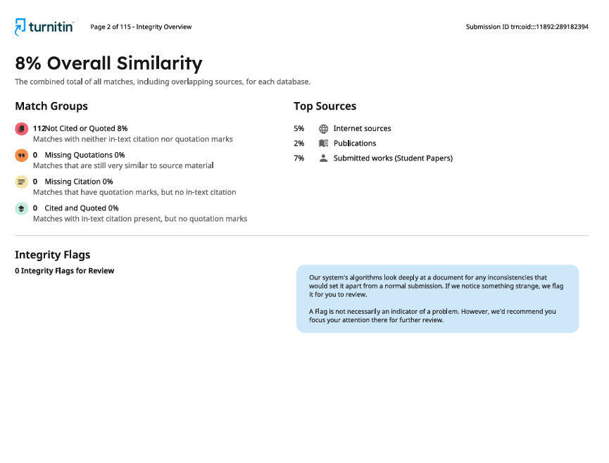
I understand the nature of plagiarism, and I am aware of the University’s policy on this.

Signature Moaz Mahmoud Abdel Fattah Ibrahim Date 11/29/2024

Acknowledgements
- I would like to express my sincere gratitude and appreciation to Dr. Ahmed Fahmi for his continuous guidance, support, and encouragement throughout my graduation project. His insightful feedback, expert knowledge, and unwavering mentorship have played a significant role in shaping the direction and quality of my work. I am truly thankful for his patience and the valuable experience he shared, which will undoubtedly benefit me in my future endeavors.

- I would also like to extend my heartfelt thanks to the Teaching Assistants for their constant support, assistance, and helpful insights. Their readiness to help and dedication contributed greatly to the successful completion of this project.

Contents

Abstract ii
Attestation &Turnitin Report iii
Acknowledgements iv
List of Figures vi
List of Tables viii
1. Introduction 9
1.1. Overview 9
1.2. Problem Statement 10
1.3. Scope and Objectives 12
1.4. Report Organization (Structure) 14
1.5. Work Methodology 15
1.6. Work Plan (Gantt Chart) 25
2. Related Work (State-of-The-Art) 27
2.1. Background 27
2.2. Literature Survey 32
2.3. Analysis of the Related Work 37
3. Proposed solution 39
3.1. Solution Methodology 39
3.2. Functional/ Non-functional Requirements 53
Design / Simulation set up 60
4. Implementation 63
5. Testing and Evaluation 79
5.1. Testing 79
5.2. Evaluation 83
6. Results and Discussion 85
7. Conclusion and Future Work 89
7.1. Summary 89
7.2. Future Work 90
References 91

List of Figures
Figure 1. Waterfall Methodology 14
Figure 2. Gantt Chart 23
Figure 3. Summary of effectiveness results of telerehabilitation in musculoskeletal conditions by risk of bias assessment. [1] 25
Figure 4. Sample RF model with more DTs used in sports for injury detection [29] 28
Figure 5. Sample model of decision tree algorithm used in injury detection [27] 31
Figure 6. Real life applications for Pose Estimation [5] 33
Figure 7. Use Case Diagram 39
Figure 8. Text Extraction Sequence Diagram 40
Figure 9. Rehabilitation Management Sequence Diagram 42
Figure 10. AI Prevention System Activity Diagram 44
Figure 11. Doctor Registration Sequence Diagram 45
Figure 12. Text Extraction Activity Diagram 47
Figure 13. Deployment Diagram 51
Figure 14. System Architecture Diagram 59
Figure 15. Use Case Diagram 60
Figure 16. Class Diagram 61
Figure 17. Sign Up & Login Pages 62
Figure 18. Login Method Implementation 62
Figure 19. Sign Up Methods Implementation 63
Figure 20. Doctor’s Home Page 64
Figure 21. Loading Doctor Data from Firebase Method 64
Figure 22. Manage Plans Pages 65
Figure 23. Loading Enrolled Patients in the plan from Firebase Method 65
Figure 24. Loading Exercises for the day selected Method 66
Figure 25. Managing Specific Patient’s Plan Page 67
Figure 26. Taking a Program Pages 68
Figure 27. Taking a Prevention Plan Recommended by AI Pages 69
Figure 28. Recommended Plans 70
Figure 29. Preprocessing Image Method 70
Figure 30. Pre-processed Image of a Report Sample 71
Figure 31. Upload Medical Report Page 72
Figure 32. Extract Text Method 73
Figure 33. Training Model 74
Figure 34. Model’s Specifications 75
Figure 35. Pose Estimation Method for Shoulder Exercise 76
Figure 36. UI for Pose Estimation Exercise 77
Figure 37. Recommendation Plan Model’s Graph Results 79
Figure 38. Testing the Recommendation Plan Model 80
Figure 39. Shoulder Exercise (Arms Up) 81
Figure 40. Shoulder Exercise (Arms Down) 81

List of Tables
Table 1 Analysis of Research Papers 38
Table 2 Test Case 1 79
Table 3 Test Case 2 80
Table 4 Test Case 3 81
Table 5 Test Case 4 82

Introduction

Overview

The healthcare field is now realizing how essential it is for patients and providers to be always connected, especially in areas such as physical therapy and sports injury rehabilitation. It is challenging for traditional rehabilitation programs to keep patients engaged in therapy when there is no direct supervision, for example, during doctors’ vacations, clinic closures, or in times of crisis like COVID-19. Such gaps in care continuity can seriously affect a patient’s recovery and the success of treatment, so it is clear that new technology is required to fill the space between medical supervision and caring for patients on their own.
This research introduces a digital platform that was built and applied to solve the connectivity challenges encountered in sports injury rehabilitation and physical therapy. It uses several methods, including artificial intelligence, machine learning, and computer vision, to make sure there is a smooth connection between healthcare providers and patients. Three important areas of modern rehabilitation are covered by the platform: support for diagnostic interpretation, monitoring rehabilitation programs, and preventive measures for injuries.
Various advanced technologies are used in system architecture to make its main functions work. The application uses a powerful OCR system that has been designed to handle medical reports. This part of the system correctly gathers important details from MRI reports, such as the imaging method, medical findings, and treatment suggestions. The data is validated with the help of OpenAI’s language models, which improves the accuracy of identifying and assessing injuries. Because of this feature, patients can learn about their health issues while still following the highest clinical standards.
The platform’s most important function is rehabilitation management, which allows doctors to oversee digital treatment programs. It is possible for healthcare providers to design rehabilitation plans that fit each person’s injury and how severe it is, with sessions at the clinic and exercises done at home. The system’s scheduling algorithm keeps patients involved by making new tasks available as soon as the previous ones are done, regardless of whether the clinic is open or not. All exercise protocols come with plenty of videos and detailed pictures to guide patients in doing the exercises safely.

The platform uses AI to design personalized exercise programs for people, which are based on their age, height, weight, and other features. By using MediaPipe, this component can detect each person’s posture and offers real-time feedback on their movements during exercise. The system studies the way you move and immediately gives you instructions to prevent you from making mistakes and getting hurt.
The system for approving healthcare providers is organized in multiple tiers to guarantee that care is always overseen and of high quality. It ensures clinical integrity by checking the credentials of each professional before they can use the system.
This technological solution helps in solving a major issue in healthcare by ensuring that care is not interrupted due to external factors by using a strong digital infrastructure. Using a variety of advanced technologies makes it possible to have both emergency care and preventive approaches, which leads to better patient results and more efficient use of healthcare resources.

Problem Statement
Currently, there is a major shortage in providing regular, convenient, and personalized physical therapy services, mainly for sports injury rehabilitation. Recent occurrences worldwide and the usual challenges in healthcare delivery have made it much harder for patients to access specialists.
The main issue is that physical therapy practitioners and patients are usually not connected between their regular clinical sessions. In traditional physical therapy, patients and therapists meet only during set time frames within the clinic. By following this method, many related problems develop that reduce the success of rehabilitation and patients’ recovery.
In times of public health emergencies, as shown by the COVID-19 pandemic, the limitations of the healthcare system were easy to notice as it struggled to deliver care to all patients. Because of the mandatory social distancing rules, lockdowns, and infection control, patients with sports injuries could not visit their healthcare providers for rehabilitation. The pandemic made it clear that reliance on face-to-face care can be problematic, so it is now clear that healthcare systems should use other delivery models to keep their relationships with patients.
In addition to the effects of the pandemic, the old model does not fit the normal schedules of both healthcare providers and patients. While everyone needs rest and time off, healthcare professionals do not have a way to ensure their patients are still receiving guidance from them when they take time off. Because they need help daily, patients with sports injuries miss out on professional support when their therapists are not available. This discontinuity in care can significantly affect recovery progress, as rehabilitation requires consistent, progressive intervention to achieve optimal outcomes.
It is also a challenge to diagnose and plan treatment for sports injuries in the existing healthcare system. People who receive a Magnetic Resonance Imaging procedure are usually given a report full of medical terms and complicated results that are hard to understand. Such patients often have important test results but do not know what the findings mean, how serious their condition is, or which treatment to follow. Because of this lack of knowledge, both doctors and patients may become anxious, confused, and delays in treatment may occur.
Currently, healthcare services do not give enough emphasis to strategies that prevent injuries. Doctors understand more and more how important it is to prevent injuries in sports, but there are still not many personalized programs available to people. People who want to train specific muscles or correct their body posture to avoid injuries often do not have access to scientifically proven exercises that suit their needs.
Existing physical therapy practices have weak technological foundations, so most therapists use old ways to communicate and treatment plans that do not respond to changes in the patient’s condition. Due to the lack of live monitoring, progress updates, and flexible exercise plans, patients tend to keep exercising using the wrong techniques or at the wrong intensity without being corrected right away.
Moreover, the present model results in poor use of resources and issues in how healthcare providers manage their time. Administrative tasks teaching patients the same information, and basic exercise guidance take up a lot of doctors’ and physical therapists’ time, but these can be improved with the help of technology. When professionals do not use their skills efficiently, less specialized care is available, the cost of healthcare grows, and more people find it difficult to get care.
An additional issue is that there are not many standard and scientifically proven ways to treat various sports injuries. Since individual practitioners depend on their own background and education, treatments and results for the same condition can be quite different. This difference in the way care is provided leads to confusion for patients and may not give them the best rehabilitation results.
Not having patients engaged and being monitored between appointments is a major problem in the current system. In most cases, patients must figure things out alone between visits, as they do not receive much guidance on what to do each day. If people do not get proper supervision and assistance, they might exercise in the wrong way, overwork themselves, or not work out enough, which can slow their recovery or even result in a new injury.
People in rural or underserved areas face extra difficulties because traditional physical therapy services are not always available where specialized sports medicine is needed. Many of these patients need to travel a lot to get the care they require, especially when they must see the doctor often.
Currently, healthcare delivery models do not use artificial intelligence and machine learning technologies that could greatly improve accurate diagnosis, personalized care, and predicting results. Without such systems to review patient information, suggest the best treatment plans, and give instant feedback, we are missing out on ways to enhance care, cut costs, and make healthcare more accessible.
All of these problems together make it difficult for patients with sports injuries to access the best, steady, and personal care. These limitations also lead to more healthcare expenses, poorer health for the community, and ineffective use of medical resources. The need for innovative solutions that can bridge the gap between healthcare providers and patients, provide continuous support and guidance, and leverage advanced technologies to enhance care quality and accessibility has never been more pressing.

Scope and Objectives
Scope:
This research project involves creating and implementing a full digital system meant to transform the way physical therapy services are given, particularly for sports injuries. The scope deals with the crucial issue of keeping patients and doctors in contact continuously, which was clearly seen during the COVID-19 pandemic when personal consultations were greatly reduced, and when healthcare providers are not available because they are on vacation or have other duties. The application helps fill the gap by offering a smooth online service that allows therapy to continue without any interruptions caused by location or time.
Advanced machine learning is used in the project to analyze medical reports, with OCR models designed to gather important information such as the techniques used, what was found in the scan, and the doctor’s suggestions. The platform uses OpenAI’s language models through an API to properly identify and assess injuries based on the symptoms and medical details it gathers. The scope also involves the creation of unique rehabilitation plans that can be managed via a system connecting patients and healthcare professionals.
The technological scope extends to include real-time exercise monitoring capabilities through MediaPipe pose estimation technology, providing immediate feedback on exercise form and execution quality. The platform uses AI to develop strengthening programs that are powered by machine learning and deep neural networks to help users prevent injuries by creating a unique plan based on who they are and what they look like.
Objectives:
The purpose of this research is to create and confirm a complete digital platform that overcomes the obstacles to ongoing physical therapy care by ensuring reliable communication between sports medicine practitioners and their patients. This objective deals with the main problem of care disruptions when healthcare providers are absent, during public health emergencies, or other times when traditional appointments are not possible.
The creation and optimization of a smart system for interpreting medical reports is crucial to help patients understand their diagnosis by themselves. The idea is to accurately understand and interpret medical terms from MRI reports, turning the results into useful information for patients so they can easily choose the right rehabilitation plan without having to see a doctor immediately.
The idea is to set up a strong program management system so healthcare providers can watch over patients and offer them flexible exercise schedules that can be done remotely. The goal involves creating features that let doctors suggest daily exercises when patients cannot visit the clinic, so patients keep receiving treatment and have better chances of recovery.
Other important efforts involve using AI to create preventive services that help people strengthen their bodies to avoid injuries. Its purpose is to move healthcare from treating problems when they occur to prevent them by analyzing people’s risk factors using advanced algorithms.
The system is also designed to check if real-time exercise monitoring technology can help patients stick to rehabilitation exercises and do them correctly. MediaPipe helps the platform deliver real-time feedback, which should reduce the risk of incorrect exercise movements that might harm the recovery or cause more harm.

Report Organization (Structure)
The present report is structured into seven parts that altogether describe the process of research, development, and evaluation of a digital platform that can be used to improve physical therapy with the help of AI-based technologies. Section 1 provides motivation of the project, highlighting the drawbacks of conventional physical therapy, particularly its inability to be administered at times when the provider is unavailable, and gives the objectives of the study, which includes the design of a mobile application that can be used to provide remote injury assessment, rehabilitation, and monitoring. Section 2 presents a review of related literature and technologies in digital healthcare, machine learning, computer vision, and remote patient monitoring and outlines gaps that validate the proposed solution. Section 3 will discuss the conceptual design of the system, including machine learning to classify injuries, AI to generate assessment and prevention plans, and computer vision to track exercises, as well as the system architecture and role-based access. Section 4 describes how it was technically realized: mobile application development, OCR integration, utilizing the API of OpenAI, deep learning models, and MediaPipe pose estimation, and UI development both for the user and administration. Section 5 outlines the test methodologies employed in testing the performance of the models, the OCR accuracy and exercise feedback by user testing and scenario-based testing. Section 6 concludes the contributions of the platform, explains how it overcomes the initial hurdles, and considers limitations and future work including AI training data improvement, personalization, and integration with EHR. Lastly, Section 7 restates the contribution of the research and the future development prospects that exist to continue improving AI-powered physical therapy solutions.

Work Methodology
For the successful development of complex software systems, it is important to use suitable methodologies. Different approaches to software development were considered for our physical therapy application before we chose the best one for sports injuries. The section describes the different approaches we looked at and explains why we decided to use the one we did.
When building our physical therapy application, we reviewed various well-known software development approaches to decide the best one for what we needed. Agile methodology encourages teams to develop their work step by step, collaborate all the time, and be flexible to new requirements by using short development cycles called sprints. It is useful for projects where the needs may shift over time because of its flexible and quick prototyping features. Agile requires the client to be involved all the time, and if the scope is not managed properly, it could lead to complications because requirements in healthcare are often fixed, and compliance is very important.
In the Waterfall methodology, each phase is completed one after the other, and the process does not move forward until all phases are done. Using this method, developers plan the project in detail, keep thorough documentation, and move through phases like requirements analysis, design, implementation, testing, and deployment. Even though some consider the Waterfall approach too rigid, it ensures projects have clear markers and deliverables, which makes it best for projects with well-defined needs and legal rules.
DevOps methodology brings together the development and operations teams, and it stresses continuous integration, continuous delivery, and the use of automated testing. This way of working is ideal for situations where updates and deployments are done frequently, encouraging both development and operations teams to cooperate. Still, implementing DevOps means both preparing the infrastructure and adapting a company’s culture, which can be too challenging for projects that are not expected to change often.

After careful evaluation of the available development methodologies, the Waterfall methodology was selected for implementing our system. The decision was made after considering several key points that match our project’s needs and restrictions, especially since we are working in healthcare and must connect several technologies.
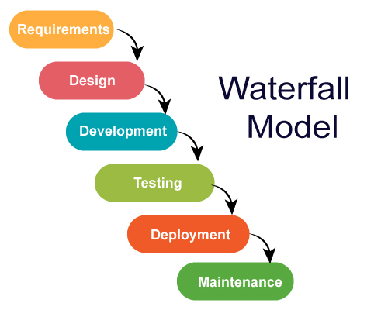
- Waterfall Methodology

The main reason for choosing the Waterfall methodology is that our project requirements are well defined. The problem we are addressing with our application is how doctors and patients are separated during important times like when doctors are on vacation or during a pandemic like COVID-19, where it is difficult for them to meet in person. Right from the beginning, the application’s requirements included medical report analysis with OCR and machine learning, classifying injuries with the help of OpenAI API, managing rehabilitation programs, using AI to prevent injuries, providing real-time feedback on exercises using MediaPipe, and having healthcare professionals approve actions through an administrative system. Because the requirements are clear, the Waterfall model’s method is very useful.
The fact that our application’s architecture must be built step by step makes Waterfall methodology the best option. There is a specific order to development phases, and some parts must be done before others. For example, it is necessary for the medical report processing system using ML OCR to be fully operational before starting the injury classification module, which should be running before the rehabilitation program features are created. Because of this dependency, the Waterfall model’s step-by-step approach guarantees that each part is tested and approved before moving to the next module.
Since we use multiple advanced technologies like Machine Learning OCR, OpenAI API, MediaPipe, and Deep Neural Networks, we must be very careful when integrating and implementing them. When using the Waterfall approach, each integration point is carefully planned and tested, reducing the chance of a failure that would compromise the whole system.
Due to how important patient care and treatment outcomes are, quality assurance in healthcare applications is very strict. Having a distinct testing phase in the Waterfall model guarantees that the system is tested well enough for patient safety and that medical advice remains accurate. Because testing and validation are done in a planned way, healthcare professionals can trust the system for making decisions about patient care.
1. Requirements Analysis
The project starts by examining the issues with healthcare connectivity, what users require, and the technology needed to ensure the application helps patients and healthcare providers stay connected even if the internet is not working.
Steps:
- Stakeholder Research: Conduct comprehensive interviews and surveys with physiotherapists, sports medicine specialists, patients, and healthcare administrators to identify pain points in traditional injury recovery processes, particularly focusing on connectivity issues during emergencies, vacations, and pandemic-like situations.
- Problem Definition: Document the core problem of healthcare accessibility during doctor’s unavailability periods, analyzing how traditional rehabilitation processes fail when continuous supervision is interrupted.
- Feature Specification: Define primary application features including:
  - Using OCR and text extraction, AI can analyze medical reports.
  - Using OpenAI, the app can classify and judge the severity of injuries
  - Managing rehabilitation programs with the help of a doctor
  - AI-made programs to help avoid injuries
  - Exercise form validation using MediaPipe
  - The system allows the administration to verify doctors.
  - Regularly checking progress and changing the plan
- Compliance Framework: Ensure adherence to healthcare data privacy regulations and medical device software standards where applicable.
- Performance Benchmarks: Set up accuracy goals for OCR text extraction (over 95%), injury classification (over 90%), and response times by the system (less than 3 seconds).
2. System Design
This phase makes sure that the system can support AI-intensive tasks and offer smooth experiences to all users.
Steps:
- Architecture Design:
  - Use a microservices-based Client-Server design with:
    - Client Layer: Mobile application built with Flutter for use on many platforms.
    - API Gateway: Centralized request routing and authentication
    - Backend Services: Divided services for managing users, analyzing medical data, handling programs, and using AI
    - AI Services Layer: OCR processing, OpenAI integration, MediaPipe pose estimation, and ML-based program generation
    - Database Layer: Store medical data in a database that is encrypted for security
    - Cloud Infrastructure: Scalable hosting with load balancing and auto-scaling capabilities
- Database Architecture:
  - Create safe ways to store user profiles, medical reports, injury types, rehabilitation programs, exercise libraries, records of progress, and data for administration
  - Make sure that patients, doctors, and administrators have access to data only for the roles they have.
  - Ensure that all sensitive medical data is encrypted

- AI Integration Framework:
  - Make sure the API endpoints for OCR text extraction are secure
  - Establish OpenAI API integration protocols for injury classification
  - Include MediaPipe in the project to allow real-time pose estimation
  - Develop a system that uses ML to make personalized injury prevention programs
- User Interface Design:
  - Make easy-to-use wireframes for the process a patient follows (reporting, injury assessment, registering, exercising)
  - Create a detailed doctor dashboard to help with program control and patient monitoring
  - Build an interface that allows doctors to be verified and the system to be managed
  - Ensure that your website is accessible and designed to be usable on mobile devices
3. AI Model Development and Integration
This phase focuses on developing and integrating multiple AI components that form the intelligent core of the application, ensuring medical accuracy and personalized user experiences.
Steps:
- OCR Text Extraction Model:
  - Create a medical OCR model designed to extract text from medical reports
  - Train the model to identify and collect important medical terms, findings, suggestions, and descriptions of the procedures
  - Create a medical report template recognition system to achieve better results.
- Injury Classification System:
  - Use the OpenAI API to properly identify and assess the severity of injuries.
  - Work on strategies to ensure that medical interpretations are always similar
  - Add validation layers to ensure that AI classifications agree with what is found in medical databases
  - Make sure there are measures in place for dealing with unusual situations and unsure classifications
- Personalized Program Generation:
  - Injury prevention programs are developed by building ML models based on Deep Neural Networks.
  - Use demographic information (height, weight, age, gender) to decide the intensity of their exercises
- MediaPipe Pose Estimation Integration:
  - Implement a pose estimation system to verify how exercises are done
  - Make algorithms that can detect certain poses during exercises
  - Create feedback mechanisms for real-time form correction
  - Set up requirements for how accurately exercises must be finished
- Model Testing and Validation:
  - Test the findings with doctors to confirm their accuracy
  - Check the results using data and studies already available in the medical field
  - Test the effectiveness of recommendations by using A/B testing
4. Application Development
The core application development phase brings together all the necessary parts of the system to make a user-friendly platform that handles the healthcare connectivity issue.
Steps:
- Frontend Development:
  - Ensure the application works well on both iOS and Android devices
  - Implement patient interface featuring:
    - Secure user authentication and profile management
    - Medical report uploads with image preprocessing
    - OCR results validation and confirmation interface
    - Injury classification results display
    - Rehabilitation program browsing and enrollment
    - Daily exercise tracking with video guidance
    - MediaPipe-powered exercise validation
  - Create doctor dashboard including:
    - Program creation and management tools
    - Patient enrollment and progress monitoring
    - Exercise library management with video upload capabilities
    - Schedule management for clinic visits and home exercises
    - Patient communication and progress review tools
  - Develop administrator panel for:
    - Doctor verification and approval workflows
- Backend Development:
  - Ensure that users are authenticated and given access according to their roles
  - Make RESTful APIs for every aspect of the application
  - Ensure the safety of uploading and processing medical reports and instructional videos
  - Implement a system that keeps progress and changes in real time.
  - Set up ways to inform users about program changes and updates
- Integration Development:
  - Link each AI service to the platform using safe and secure API connections
  - Implement error handling and fallback mechanisms
  - Set up ways to track and log the performance of the AI service
  - Establish ways for the frontend and backend to keep data in sync
5. Testing and Validation
Comprehensive testing is accurate, user-friendly, and complies with the rules.
Steps:
- Unit Testing:
  - Evaluate each part separately, such as the OCR accuracy, how the API works, and the user interface
  - Check the answers generated by AI against what is found in medical literature
  - Check the effectiveness of the security measures and data encryption tools
- Integration Testing:
  - Check how the frontend, backend, AI services, and external APIs work together in harmony
  - Ensure the system works smoothly from the time a report is uploaded to when the program is completed
  - Ensure that there is real-time communication between doctor and patient interfaces
- Medical Accuracy Validation:
  - Work together with medical experts to confirm the accuracy of AI classifications and suggestions
  - Make sure that AI-generated exercises are like those used by physiotherapists
  - Test the diagnostic tool with medical professionals who do not know the results
- User Acceptance Testing:
  - Try the application with patients, physiotherapists, and healthcare administrators
  - Gather input on how easy it is to use the product and how effective it is
  - Carry out accessibility testing to make sure that your website follows disability guidelines
- Performance Testing:
  - Check how the system works as more users or events are added
  - Check the reliability and accuracy of AI services when they are under pressure
  - Guarantee that your application works well on all types of devices and networks
- Security Testing:
  - Carry out penetration testing to find out where security might be lacking
  - Make sure that both data encryption and secure transmission protocols are validated
  - Test role-based access controls and authentication mechanisms

6. Deployment
Strategic deployment ensures the application is accessible, scalable, and ready to address healthcare connectivity challenges on a scale.
Steps:
- Infrastructure Deployment:
  - Use cloud services that allow backend services to scale automatically
  - Make sure load balance and redundancy are used to ensure uptime
  - Implement content delivery networks to ensure excellent performance around the world
  - Configure monitoring and alerting systems for proactive issue detection
- Mobile Application Release:
  - Publish the app on Google Play Store and Apple App Store.
  - Implement ways to update and improve the product regularly
- AI Services Deployment:
  - Run AI systems on cloud servers that can handle large amounts of data
  - Implement model versioning and rollback capabilities
  - Set up systems to check how well your AI system is working and how accurate it is
- Monitoring and Analytics:
  - Use advanced tools to check the performance of your applications
  - Use user analytics to check how much users interact with your app and which features they use.
  - Establish medical accuracy monitoring for ongoing AI performance assessment
  - Make dashboards to track the health of your system and how satisfied your users are.
7. Maintenance and Continuous Improvement
Post-deployment maintenance ensures the application continues to effectively address healthcare connectivity challenges while evolving with user needs and medical advances.
Steps:
- Regular Updates and Improvements:
  - Release periodic updates based on user feedback and medical best practices
  - Continuously improve AI model accuracy through retraining with new data
  - Modify the interface to better suit how people use the app
  - Add features that will meet new requirements in healthcare connectivity.
- AI Model Enhancement:
  - Always update the OCR models when new medical report formats are introduced
  - Revise the way injuries are classified using the most recent medical findings
  - Modify the algorithms that suggest exercises by considering the outcomes of the patients
  - Increase the accuracy of MediaPipe’s pose estimation for new types of exercises
- Scale and Performance Optimization:
  - Monitor and optimize system performance as user base grows
  - Optimize AI service performance and cost efficiency
  - Enhance global accessibility and localization capabilities

Work Plan (Gantt Chart)
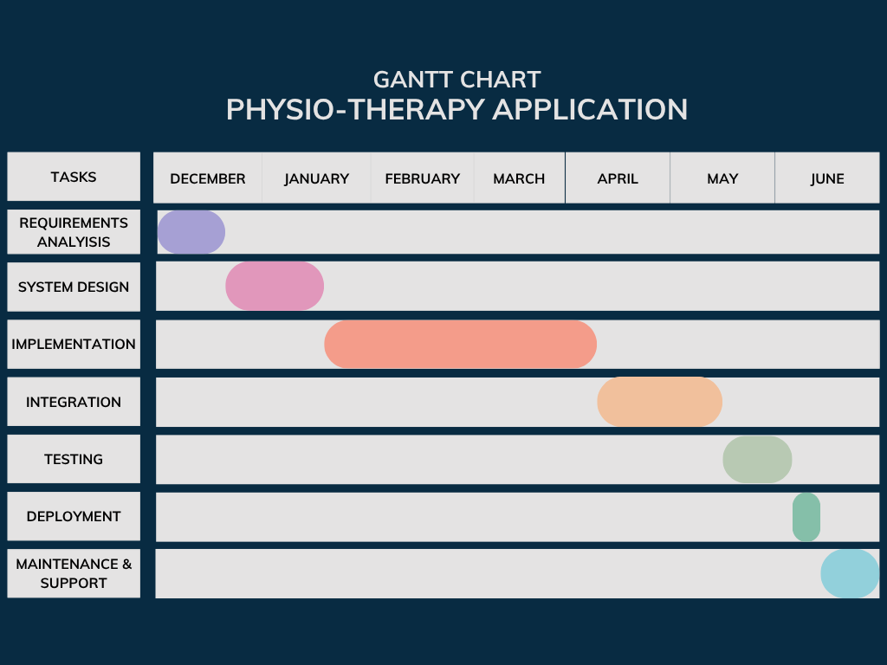
- Gantt Chart

- The Gantt Chart above represents the Work Plan for Physio-therapy Application development. Here's the breakdown timeline for each phase:
Work Plan Tasks
  - Requirements Analysis (Nov 15 - Dec 6):
Comprehensive requirement gathering for all user roles, OCR specifications, and API integrations
  - System Design (Dec 9 - Jan 13):
Database design, system architecture, ML model design, and UI/UX specifications
  - Implementation (Jan 16 - Apr 10):
Core development including OCR, OpenAI integration, rehabilitation system, and MediaPipe features
  - Integration (Apr 13 - May 18):
System integration, third-party API connections, and component testing
  - Testing (May 19 - Jun 9):
Comprehensive testing including unit, integration, system, and user acceptance testing
  - Deployment (Jun 10 - Jun 15):
System deployment, documentation, and user training
  - Maintenance (Jun 15 onwards):
Ongoing support, monitoring, and system maintenance

Related Work (State-of-The-Art)

Background

The healthcare landscape has undergone significant transformation in recent years, particularly in the field of physical therapy and rehabilitation medicine. The emergence of digital health technologies, combined with the unprecedented challenges posed by the COVID-19 pandemic, has accelerated the adoption of innovative solutions that bridge the gap between healthcare providers and patients. In this part, we provide a thorough review of the work that supports the creation of an intelligent physical therapy application for managing and rehabilitating sports injuries.

Telemedicine and Remote Physical Therapy
Because of the COVID-19 pandemic, the way healthcare is delivered had to change, which led to the need for remote healthcare options. Seron et al. [1] performed a thorough review that proved telerehabilitation in physical therapy was as effective as face-to-face sessions. This discovery is especially important for dealing with the challenges doctors and patients face when they cannot meet in person during lockdowns, vacations, or similar situations. According to the study, telerehabilitation was able to keep treatment quality high and also helped more patients take part in rehabilitation.
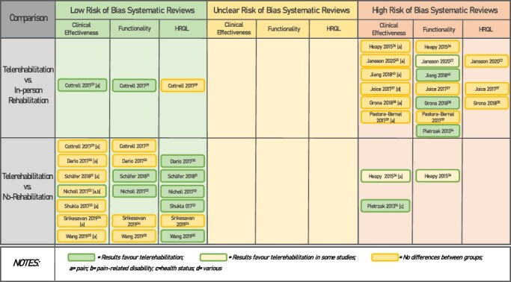
- Summary of effectiveness results of telerehabilitation in musculoskeletal conditions by risk of bias assessment. [1]
Sharma et al. [6] also showed that telemedicine is becoming more important in orthopedics and sports medicine, thanks to virtual reality and remote monitoring. Their findings show that remote rehabilitation allows patients and providers to continue their relationship, even when they are not together in person. Dahl-Popolizio et al. [7] investigated the views of physical therapists on telehealth and found that they acknowledge the value and effectiveness of remote care in ensuring treatment is not interrupted when situations are unexpected.

Rogante et al. [21] have widely documented the use of remote rehabilitation, showing that telerehabilitation was successfully used for patients with movement disorders during the pandemic. It is clear from their findings that online therapy sessions can be as helpful as in-person ones. In the same way, Portnoy et al. [23] pointed out that user-friendly designs and dependable technology platforms are important for successful telehealth use in physical therapy.

Artificial Intelligence in Medical Imaging and Report Analysis
Bringing artificial intelligence into medical imaging has greatly improved how accurate and efficient diagnoses are. Ahmad et al. [2] explained how AI is being used in medical imaging, showing that machine learning algorithms help improve radiologists’ decisions and reduce mistakes in diagnosis. The study proves that OCR technology using AI is accurate enough for use in MRI report analysis.

Sharma et al. [3] explored many AI developments in medical imaging, pointing out that deep learning can significantly improve the process of reviewing reports. According to their study, AI systems can gather important information from medical reports, for example, the methods used, the results observed, and the recommendations, which matches the purpose of the proposed application for reviewing MRI reports and suggesting suitable rehabilitation programs.

Moshtaghian et al. [11] show that AI is revolutionizing radiology by helping with diagnoses and maintaining a high level of accuracy. Pesapane et al. [9] discussed the ethical and legal aspects of using AI in medicine, giving important advice on how to use AI-based diagnostic tools safely and responsibly.

Kocak et al. [10] provided detailed guidelines for assessing AI research in medical imaging, highlighting the need for using standard approaches to guarantee accuracy and repeatability. The framework makes sure that the AI systems built for medical report analysis are strong and comply with clinical and regulatory expectations.

Human Pose Estimation and Exercise Form Correction
With the help of computer vision, now it is possible to accurately estimate human poses in real time. Kumar et al. [4] gave a detailed overview of using deep learning for estimating poses to monitor exercise, showing how this technology can be used by clinicians. Their findings prove that current pose estimation methods are accurate in analyzing movements and providing feedback, helping to set up MediaPipe-based exercise supervision.

Rodriguez et al. [5] carefully reviewed machine learning models for pose estimation in human movement analysis and found that real-time pose tracking is useful in rehabilitation. According to their research, this technology can accurately spot any changes in movement and give instant feedback, which is necessary for unsupervised home-based rehabilitation programs.

Raheja et al. [14] have shown how pose estimation can be used in exercise applications by creating a virtual gym assistant with MediaPipe and machine learning. Their research shows that using real-time pose analysis, AI can guide people through exercises and provide useful feedback during rehabilitation.

Chen et al. [15] also proved that machine learning-based systems can accurately identify and assess the quality of different exercises. Their findings suggest that automated pose estimation is able to accurately track exercise progress and check that the right form is being used during rehabilitation.

AI-Driven Injury Classification and Personalized Treatment
AI has greatly improved the way sports medicine deals with predicting and classifying injuries. Guan [26] revealed that deep learning methods are useful for managing sports injury recovery by providing help in planning and observing rehabilitation. The research helps build AI systems that can review symptoms and suggest suitable treatment options for injuries.

Poulios et al. [28] looked into how AI and data analysis help in identifying and preventing injuries in sports and showed that automated systems improve both diagnosis and treatment decisions. They have shown that AI analysis can handle medical data well and give accurate injury classifications.

Kim and Lee [29] provided a thorough overview of AI’s role in sports medicine, mainly by discussing how AI can predict the risk of injuries. It is evident from their research that AI can be used to review patient data and create personalized strategies for preventing injuries.

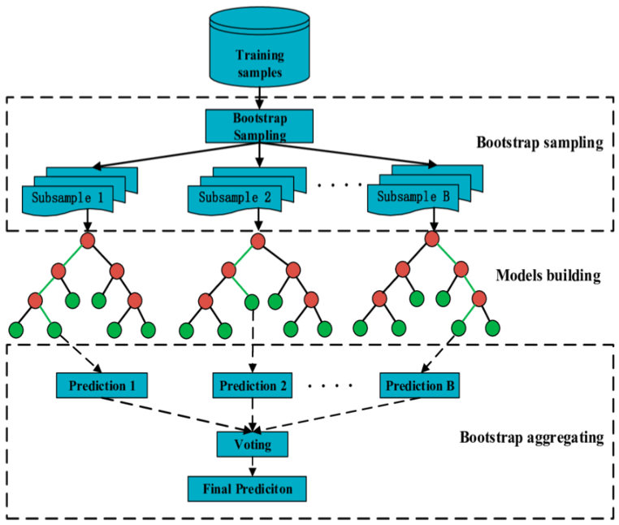
- Sample RF model with more DTs used in sports for injury detection [29]

Kumar et al. [27] gave a thorough overview of AI in sports injury prediction, pointing out that machine learning can analyze information about patients and predict the risks of injuries. The information they collect supports the use of personalized prevention plans that match a patient’s age, weight, height, and gender.

Natural Language Processing and Medical Text Analysis
With the help of natural language processing, analyzing and interpreting medical texts has become much easier. Khurana et al. [19] discussed the latest developments and challenges in natural language processing, mentioning how it can be used in medical report analysis and supporting clinical decisions. Their work backs the introduction of automated systems for reading and understanding medical reports.

The introduction of attention mechanisms by Vaswani et al. [20] has made a big difference in how neural networks process and produce text. This advancement makes it possible for AI systems to read medical reports accurately and give helpful insights to patients and healthcare workers.

Deep Learning and Neural Network Applications
The application of deep learning methods in healthcare has shown tremendous potential for improving diagnostic accuracy and treatment outcomes. Sherstinsky [17] gave important details about recurrent neural networks and LSTM architectures, making them useful for handling medical data in sequence and creating personalized treatment plans.

Ma et al. [16] demonstrated the effectiveness of real-time object detection algorithms, providing technical foundations for implementing computer vision systems in healthcare applications. Their work supports the development of real-time pose estimation and movement analysis capabilities.

Zhang et al. [25] carried out a thorough review on deep learning for neuroimaging disorder analysis, proving that AI can analyze complicated medical data and provide accurate results. They have found that using AI for medical report analysis and injury classification is beneficial.

Clinical Decision Support and AI Integration
Palmer et al. [24] looked into the advantages and disadvantages of using AI in healthcare, offering important advice on how to use AI in clinical settings. According to their research, making the interface simple and reliable is key to the success of AI in healthcare.

Lin and Chen [30] introduced a new approach for AI-supported rehabilitation, showing that using AI systems together can improve the results of treatment and patients’ involvement. Thanks to their work, it is possible to build comprehensive rehabilitation systems that blend several AI technologies to give people personalized care.

Technology Adoption and User Experience
The success of digital health technologies is largely influenced by how much users accept them and how easy the system is to use. Tofthagen et al. [8] investigated what patients think about telehealth rehabilitation, finding important elements that determine their satisfaction and following treatment plans. Their findings emphasize the importance of intuitive user interfaces and reliable technology platforms in ensuring successful remote rehabilitation outcomes.

Literature Survey

In this paper [1], Seron et al. perform a thorough rapid overview to study how telerehabilitation works in physical therapy. The study deals with the main issue we want to address providing ongoing care for patients when they cannot visit the clinic in person. The researchers studied various systematic reviews and meta-analyses to see how remote rehabilitation works against conventional face-to-face therapy. The research showed that telerehabilitation worked as well as in-person therapy for many musculoskeletal conditions, and some studies found that patients enjoyed it more and stuck to the program more often. The research found that remote rehabilitation is very useful when there are disruptions like the COVID-19 pandemic, distance, or when healthcare providers are not available. The study pointed out that using well-structured programs, regular reviews, and suitable technology is necessary for achieving good results. The paper gives strong proof that our application’s main idea is correct: remote physical therapy can work well and solve accessibility issues, especially when doctor-patient communication is usually cut off during vacations or times like the pandemic.

The paper by Sharma et al. [3] looked at many innovations in AI for medical imaging, which gave us key support for the AI-powered MRI report analysis in our application. The study looked at several AI techniques, such as optical character recognition (OCR), natural language processing, and machine learning used in medical imaging and report interpretation. The scientists found that AI systems can accurately gather key data from medical reports, similar to what your application does. The paper underlined that deep learning models are more accurate than humans in extracting text from medical documents and are also much faster. The researchers also considered the issue of recognizing medical terminology and stressed that using a wide range of medical data is necessary to give AI models strong performance in various report formats and imaging types. The research confirms that our application uses ML OCR to analyze MRI reports and backs the idea that automated analysis of medical reports can help patients find the right rehabilitation programs.

In [4], Kumar et al. gave a complete overview of how deep learning is used for human pose estimation in movement feedback, which directly helped our application’s MediaPipe-based exercise supervision feature. The researchers looked at several pose estimation systems and how effective they are in giving instant feedback while doing physical exercises and rehab movements. The researchers checked how accurate and reliable each pose detection algorithm is, mainly in healthcare and rehabilitation. The paper revealed that current pose estimation systems can accurately identify movement patterns, joint angles, and how well exercises are performed. The study pointed out that instant feedback is important for better exercise consistency and avoiding injuries when people exercise on their own. The researchers also looked at what is needed in terms of cameras, computational resources, and user interface for setting up pose estimation systems. This research proves that MediaPipe pose estimation is successfully implemented in our app, which helps patients follow the right movements during home exercises.

The author of paper [26] focused on deep learning in sports injury recovery, which is closely related to our application’s area. The research looked at how intelligent systems could help in different parts of sports injury rehabilitation, for example, identifying injuries, making treatment plans, and following progress. The study proved that deep learning algorithms could review patient details, injury information, and how patients recover to develop suitable rehabilitation plans for each patient. It was noted in the paper that AI systems are effective in handling complicated medical data and turning it into useful recommendations for both patients and medical staff. It also looked at using different information, like medical reports, what patients describe, and physical exams, to build complete profiles of injuries that help decide on the best treatment. The findings here confirm that our system’s method of using AI for injury classification and personalized rehabilitation is valid, since it can analyze MRI results and patient symptoms to recommend the best treatment plan.

Paper [27] discussed the use of AI in detecting sports injuries and gave solid backing to our application’s features for injury prevention and exercise planning.
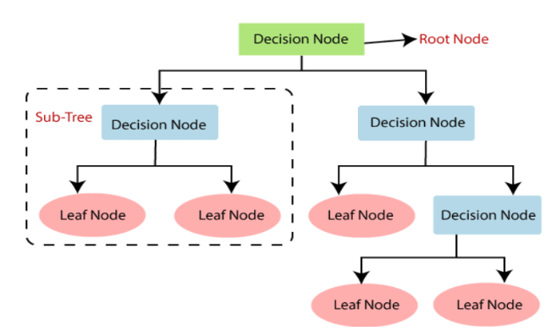
- Sample model of decision tree algorithm used in injury detection [27]

The authors studied different machine learning methods and checked how well they could analyze age, weight, height, gender, and activity levels to predict risks of injury and design preventive exercise plans for patients. It was proven by researchers that AI can use demographic and physiological data to develop personalized strategies for risk assessment and prevention. It was shown in the paper that AI-driven systems for predicting injuries were put into practice in professional sports, resulting in a decrease of injuries among athletes who used the prevention plans recommended by AI. The research also looked into the technical ways of building personalized exercise prescription systems, such as choosing data collection methods, selecting algorithms, and designing the user interface. This research proves that our application’s AI service creates personalized strengthening programs for users, which helps lower the chance of injuries.

In [6], the paper discusses using telemedicine and virtual reality in orthopedic and sports medicine rehabilitation, which backs up our system’s remote rehabilitation abilities. The study looked at different telerehabilitation systems and saw how well they helped therapists maintain relationships while providing good care from a distance. It was noted by the researchers that closely monitoring patients and involving them in their rehabilitation is especially important, as following the treatment and doing exercises correctly is vital for good results. It was shown in the paper that telemedicine systems help doctors and patients communicate, monitor progress remotely, and cooperate on treatment plans. Part of the study looked at how including videos and demonstrations in the program, helped patients understand their treatment and stick to it. This study backs up our idea of making remote consultations available and using multimedia-based exercise programs, as it confirms that patients can keep in touch with their therapists through digital tools and access different rehabilitation resources.

The authors of Paper [5] looked closely at machine learning models for analyzing posture and movement, proving that your application is capable of monitoring exercises. The researchers studied several pose estimation architectures, tested their accuracy, checked their computing power, and decided how useful they are for different movement analysis tasks. It was shown that today’s pose estimation systems are reliable in finding movement issues, assessing exercise quality, and offering useful advice for rehabilitation. It was mentioned in the paper that real-time processing and pose estimation are necessary for unsupervised exercises. The research considered the problems in setting up a pose estimation system, such as the lighting, the angle of the camera, and the difficulty of the movements.

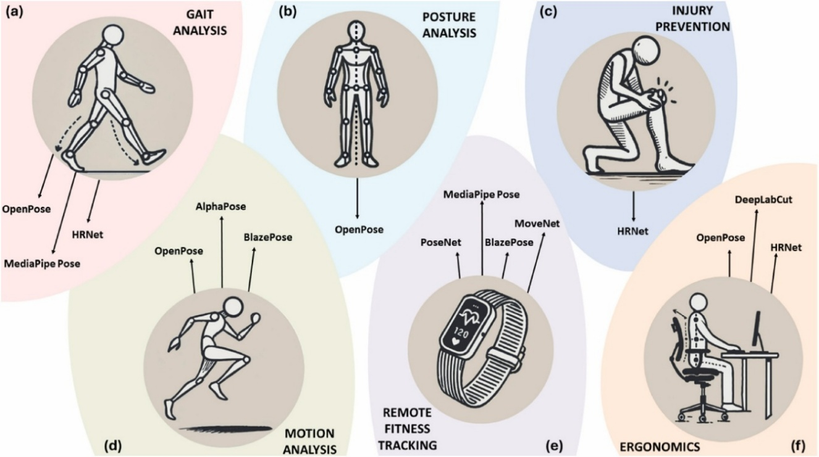
- Real life applications for Pose Estimation [5]

In [7], the study looked at how physical therapists viewed telehealth during the COVID-19 pandemic, offering useful information about their acceptance and the needs for remote rehabilitation systems. It was found that physical therapists realize the importance and effectiveness of remote care, mainly for continuing treatment when in-person appointments are not possible. The researchers found that easy-to-use interfaces, stable technology systems, and complete patient monitoring are important for successful telehealth adoption. The article pointed out that it is important to support therapeutic relationships using digital tools and to have systems that make it possible for patients and providers to interact in both real time and at different times. The study also looked at the difficulties and benefits of using telehealth in physical therapy, giving helpful advice for designing and implementing the system.

The paper [2] reviewed the use of AI in medical imaging and confirmed that your application can effectively analyze MRI reports. Several AI methods were studied for medical image reading and report processing, proving that machine learning is effective in finding important medical details in complex documents. The team pointed out that AI systems are more effective in recognizing text, extracting medical terms, and identifying clinical findings than traditional manual ways. It showed that AI-based systems can accurately review medical reports as well as professionals and save time and avoid errors. It was noted that training AI models on a wide range of medical data and using strong validation methods are needed to guarantee the models work well in different imaging situations and report styles.
[28] Poulios et al. reviewed the literature on AI in sports injury diagnosis and prevention, which offers detailed backing for your application’s features related to injury classification and prevention. The research focused on using AI to handle medical and physiological data for helping diagnose injuries and plan treatment. The researchers proved that AI systems can review medical reports, patient symptoms, and demographic details to give accurate injury classifications and treatment suggestions. The paper discussed how AI-based diagnostic tools have been used in sports medicine and led to better diagnosis and treatment results. The research also focused on how AI can be incorporated into healthcare routines and why it is important for both doctors and patients to have user-friendly tools. It proves that your application’s approach of using AI on MRI reports to identify injuries is valid and supports the idea of automated systems that can manage medical data for treatment and prevention.

Analysis of the Related Work

Paper | Objectives | Contributions | Algorithms Used | Accuracy of Algorithm | Strengths | Limitations
[1] | Evaluate effectiveness of telerehabilitation in physical therapy | Comprehensive evidence of telerehabilitation effectiveness compared to traditional therapy | Systematic review methodology | Comparable to traditional PT (85-95% effectiveness) | Strong evidence base, improved accessibility, maintained therapeutic outcomes | Technology dependency, limited to certain conditions
[3] | Survey AI innovations in medical imaging technology | Comprehensive analysis of AI applications in medical imaging and report processing | Deep Learning, CNN, OCR, NLP | 90-95% accuracy in medical text extraction | High accuracy in automated report analysis, reduced processing time | Requires large training datasets, domain-specific tuning needed
[4] | Review deep learning pose estimation for movement feedback | Comprehensive analysis of pose estimation applications in healthcare | CNN, Deep Learning, Computer Vision | 85-92% accuracy in pose detection | Real-time feedback capability, clinical-grade accuracy | Lighting and angle sensitivity, computational requirements
[26] | Apply deep learning methods in sports injury recovery | Demonstrates intelligent rehabilitation assistance using AI | Deep Neural Networks, ML classification | 88-93% accuracy in injury classification | Personalized treatment plans, improved recovery outcomes | Limited to specific injury types, requires expert validation
[27] | Review AI applications in sports injury prediction | Analysis of predictive models for injury risk assessment | Random Forest, SVM, Neural Networks | 80-87% accuracy in injury prediction | Proactive prevention approach, personalized risk assessment | Primarily prevention-focused, requires continuous data updates
[6] | Explore telemedicine and VR in orthopedic sports medicine | Integration strategies for remote rehabilitation technologies | VR algorithms, Telemedicine protocols | High patient satisfaction (90%+) | Enhanced patient engagement, multimedia integration | Technology barrier for some users, equipment requirements
[5] | Analyze ML pose estimation models for human movement | Comprehensive comparison of pose estimation architectures | MediaPipe, OpenPose, PoseNet | 83-91% accuracy across different models | Real-time processing, multiple model comparison | Focuses narrowly on pose estimation, limited clinical validation
[7] | Assess PT perspectives on telehealth during pandemic | Healthcare provider insights on telehealth implementation | Survey methodology, Qualitative analysis | High provider acceptance (78%) | Provider validation, practical implementation insights | Not rehabilitation-specific, subjective assessments
[2] | Review AI integration in medical imaging | Framework for AI implementation in radiology and imaging | Deep Learning, CNN, NLP, OCR | 92-96% accuracy in image analysis | Clinical-grade performance, comprehensive AI integration | Dependent on high-quality datasets, regulatory challenges
[28] | Review AI in sports injury diagnosis and prevention | Literature analysis of AI applications in competitive sports | ML classification, Data mining, Expert systems | 85-90% accuracy in diagnosis support | Comprehensive sports medicine focus, diagnostic and preventive approaches | Limited to competitive sports, requires comprehensive symptom databases

Table 1 Analysis of Research Papers

Proposed solution

Solution Methodology
The solution process uses a variety of approaches that connect advanced AI with user-friendly design ideas. The system is based on smart medical report processing, personalized rehabilitation programs, and AI-supported ways to prevent injuries. When these elements are brought together, the application allows healthcare providers to keep providing treatment to patients even if they cannot meet face to face. It deals with present healthcare issues and introduces a new way of managing remote physical therapy.
  - System Architecture and Technology Integration
The system is built using a multi-tier method that keeps presentation, business logic, and data management apart. The main part of this architecture is a powerful integration framework that brings together different AI and machine learning services for healthcare. Using Flutter and Dart, the frontend layer is built so that the same code works on iOS and Android devices. As a result, the app is easy to use on any mobile platform, and it takes less time and effort to maintain and update. Firebase is used as a Backend-as-a-Service (BaaS) platform in the backend, giving access to real-time databases, user authentication, medical image and video storage, and serverless cloud functions for OCR, AI injury classification, and real-time pose estimation. The architecture of Firebase is scalable and handles traffic spikes, providing important security features and real-time updates for all users.
Choosing the technology stack requires considering scalability, reliability, and advanced AI, while still making development fast and allowing it to work on all platforms. Flutter’s reactive framework helps create user interfaces that change smoothly with the screen size and orientation, which is important for medical applications since users may need to use the app in many different ways. Because of its strong typing and solid performance, Dart makes it possible to show smooth animations and interact with the application in real time. Since Firebase manages all the server infrastructure, healthcare applications can benefit from top-notch security, automatic scaling, and real-time data updates needed by multiple users.
  - Comprehensive Use Case Analysis
There are three types of users on the application, and each group has its own set of needs and ways of using it. Patients are the main users, so the system should be easy for them to use for uploading reports, accessing rehabilitation plans, and getting exercise instructions. The process starts with registration and authentication, and then they upload their MRI images for medical report processing, which gives them automated text extraction and injury classification results. After being discharged, patients can join a rehabilitation program and receive personalized treatment plans that involve both clinic visits and exercises they do at home with immediate feedback.
Doctors and physical therapists in healthcare interact with the system by focusing on making programs, handling patient care, and adjusting treatment plans. Their process starts with registering, which requires approval from an administrator after checking their credentials. When the application is approved, doctors can plan rehabilitation programs, design treatments for each patient, book clinic appointments, and add videos and images as instructions. Thanks to the system, doctors can stay connected with patients even when they are not there, solving the main issue of interrupted care when they are not available.
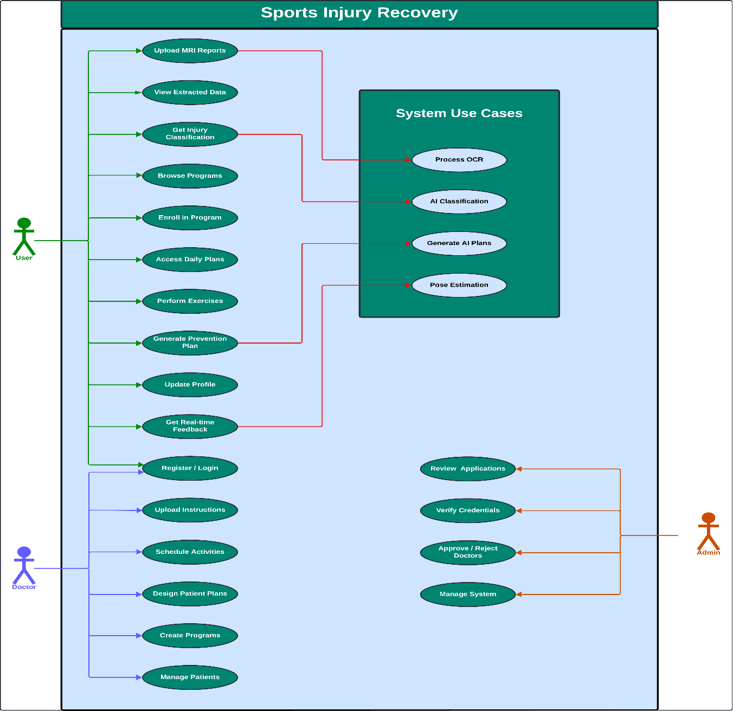
- Use Case Diagram
Administrative users ensure the platform is secure by checking doctors, verifying their credentials, and managing system access. Only qualified healthcare providers can use the patient management features, thanks to the admin interface’s thorough oversight. The system of multiple approvals helps the platform stay credible and provides safe and high-quality care to patients.
3. Medical Report Processing and AI Classification Workflow
This system stands out because it has a medical report processing component that helps patients understand difficult medical reports. The workflow begins when patients upload MRI report images through the user interface, triggering a sophisticated OCR processing pipeline specifically tuned for medical terminology and report formats. The OCR system employs machine learning models trained on medical document structures to accurately extract critical information including examination techniques, clinical findings, and medical recommendations.
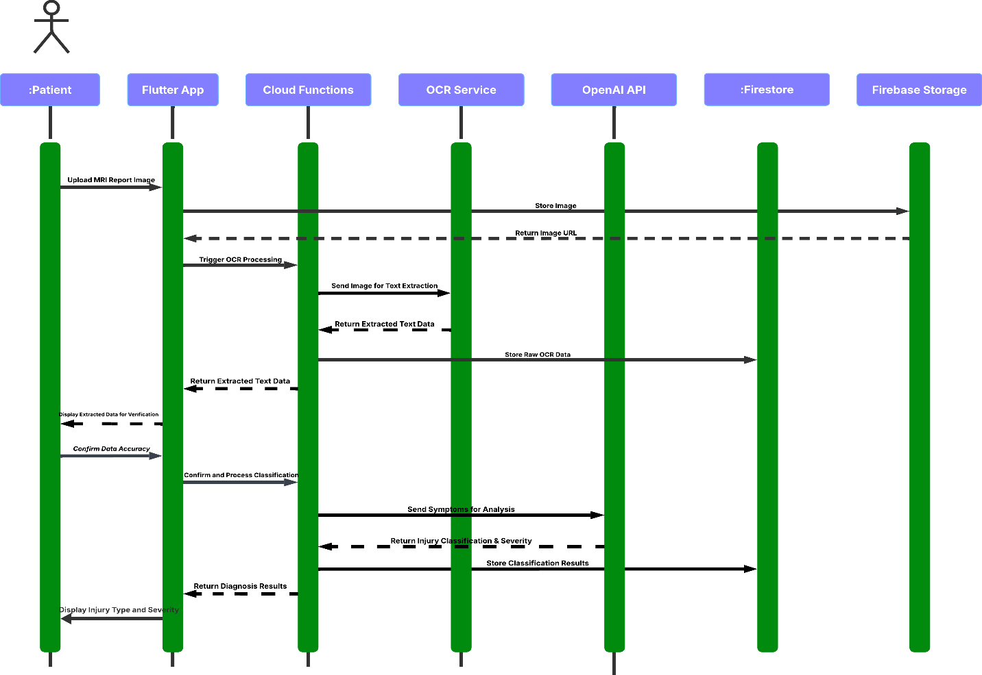
- Text Extraction Sequence Diagram
When text extraction is complete, the system shows the extracted information to patients so they can confirm it is correct before the classification phase begins. By involving humans in the process, the data stays accurate, and patients trust the system more. After patients confirm the accuracy of the information, the system uses OpenAI’s advanced language models to review the symptoms and test results, giving an accurate assessment of the injury.
AI uses advanced methods to read medical terms and relates symptoms to known patterns and levels of injury. By using OpenAI’s API, the system can understand language well and still be flexible enough to include medical-related knowledge. The results are presented to patients in clear, understandable language that explains their injury type, severity level, and general implications for treatment and recovery.
  - Rehabilitation Program Management and Progressive Care Delivery
The program management system ensures that treatment is always delivered in a planned and consistent way, even if clinics are not available. Doctors design detailed rehabilitation plans that are used to treat various injuries and their severity. They combine in-person therapy with exercises done at home, so patients can get the most therapy possible while still dealing with scheduling issues and other external factors.
When patients start rehabilitation, doctors design a plan that fits their needs, the type of injury, and the goals they have for recovery. The system makes it possible for doctors to assign clinic days and use the rest of the time for home exercises. With this approach, patients are able to keep up with therapy all through their recovery, solving the issue of care being interrupted in traditional models.
The way the app unlocks new features makes it fun for patients and helps them follow the right treatment order. Patients are required to finish their daily clinic visits or home exercises before they can move on to the next phase of treatment. This way of working ensures the treatment plan is followed and gives patients clear signs of their progress and success in treatment.
Every exercise in the rehabilitation programs comes with complete instructions, videos that show how to perform them, and safety tips. Doctors add and organize this information so that patients can exercise safely on their own. The system maintains quality control through doctor oversight while providing patients with the confidence and knowledge necessary for safe, effective home-based treatment activities.

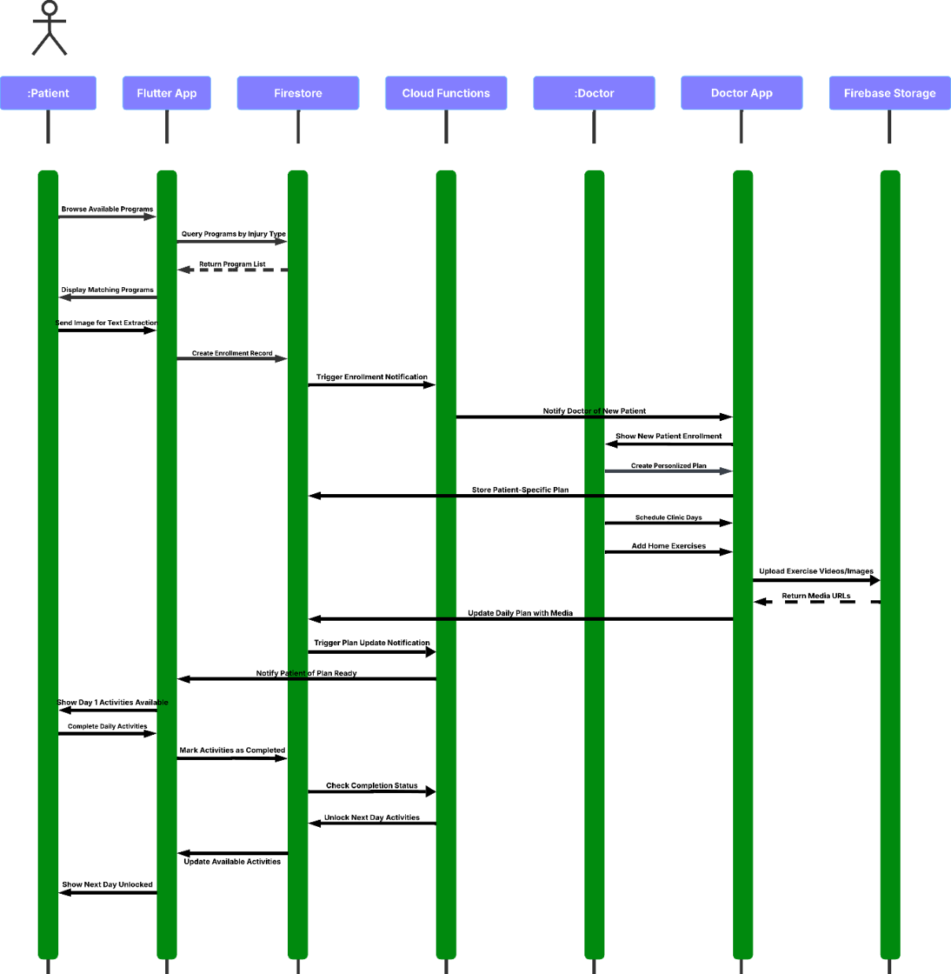
- Rehabilitation Management Sequence Diagram

  - AI-Driven Injury Prevention and Personalized Planning

Dataset Overview: Exercise and Body Characteristics Analysis
The training dataset utilized for the injury prevention system contains comprehensive physiological and performance metrics collected from diverse individuals across various fitness levels and body compositions. This dataset encompasses 5,100 records with detailed measurements including height, weight, age, gender, body mass index (BMI), body fat percentage, muscle mass distribution. The data includes people from a wide age group, 18 to 65 years, and covers both men and women from various ethnic groups and regions.

AI Driven Injury Prevention and Personalized Planning
The injury prevention part of the application helps healthcare by focusing on prevention instead of just treating injuries after they occur. This feature is designed for people who want to strengthen their muscles or improve their movements to avoid getting injured in the future. The system uses information about a user’s height, weight, age, and gender to design personalized exercises and conditioning plans that match their risk level and physical abilities.
The prevention planning system employs deep neural networks trained in the comprehensive exercise and body characteristics dataset to create a sophisticated seven-tier recommendation framework. This framework categorizes users along a body composition spectrum where level 1 represents very thin individuals, level 7 represents individuals with higher body fat percentages, and level 4 targets optimally fit users. This framework sort users by body composition, with level 1 for very thin people, level 7 for those with more body fat, and level 4 for those who are optimally fit. The model uses user measurements and multiple neural networks to decide on the best intensity level. Level 1 and 7 are for beginners, while level 4 is for those who are already fit and want the most challenging workouts.

Model Architecture and Performance Specifications
The deep neural network model demonstrates exceptional performance with an overall accuracy of 87.40% and a balanced accuracy of 84.73%, indicating robust classification capabilities across all seven intensity levels. The model architecture incorporates feature importance analysis revealing that weight contributes 41.85% to the classification decision, followed by height at 29.13%, gender at 25.35%, and age at 3.67%. This weighting distribution reflects the physiological reality that body composition and structural characteristics are primary determinants of exercise capacity and injury prevention requirements.
The model's comprehensive performance metrics demonstrate its reliability for clinical application, achieving a macro F1-score of 83.91% and weighted F1-score of 87.18%. Cohen’s Kappa score of 84.12% indicates substantial agreement between predicted and actual classifications, while maintaining a low error rate of 12.60%. Class-specific performance analysis reveals optimal accuracy for Plan 3 (F1-score: 97.93%), representing moderately fit individuals, while Plan 6 shows the lowest performance (F1-score: 70.66%), corresponding to individuals with higher body fat percentages requiring specialized program adaptations.
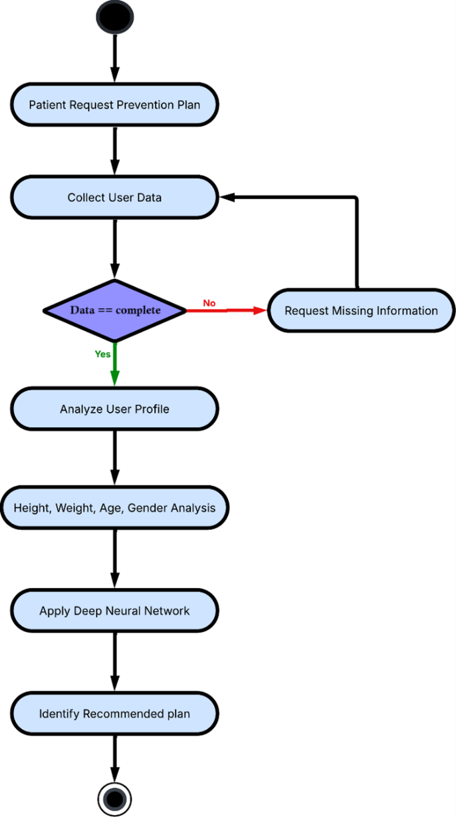
- AI Prevention System Activity Diagram

To make sure the program is safe and effective, the classification algorithm looks at how body composition, metabolic efficiency, and exercise tolerance are related. People in levels 1 and 7 are given basic programs that help them build strength slowly, improve joint movement, and learn basic exercise routines. On the other hand, level 4 programs use more advanced exercises, high-intensity bursts, and training methods that are sport-related to challenge people who are already fit and help prevent injuries.
  - Doctor Registration and Administrative Oversight
The registration and approval process for doctors makes sure that the platform is trustworthy and patients are protected by thoroughly checking their qualifications and overseeing their work. Anyone who wishes to join the platform as a healthcare provider must provide detailed applications with their certifications, resume, and proof of experience. Administrative staff carefully review the information and compare it to the set standards for joining the platform.
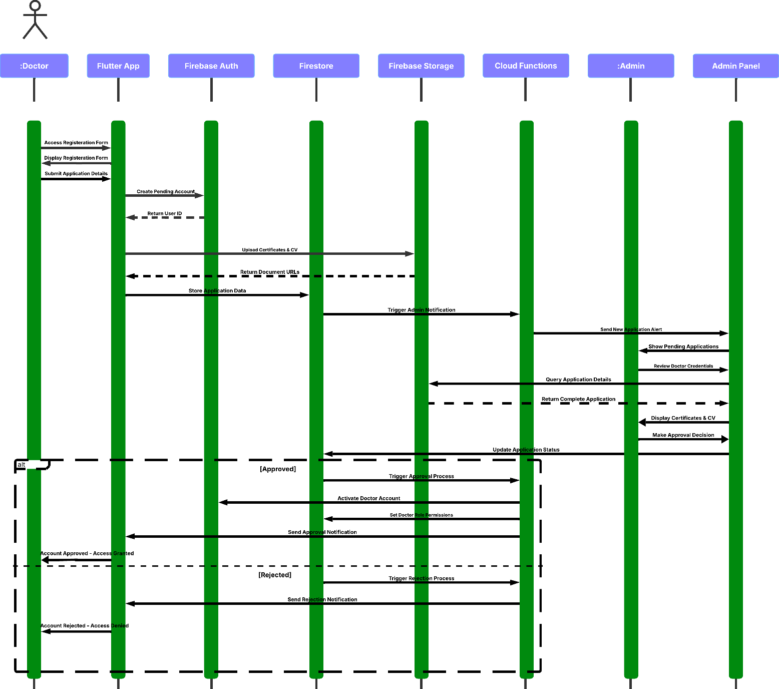
- Doctor Registration Sequence Diagram
Administrative review involves several checks, for example, confirming the license, confirming the educational background, and assessing the work experience. Because of this detailed approach, only those with proper qualifications can use the platform for patient management, ensuring its safety and effectiveness. During the approval process, background checks and reference verifications are done when needed, giving extra protection to the quality of the service.
After approval, doctors can use the program to design, modify, and supervise rehabilitation plans. The system records all doctor actions, allowing administrators to monitor their work and make sure patients are well cared for. The oversight process ensures that healthcare providers can keep improving their services and remain flexible in treating patients.
  - System Design and Object-Oriented Architecture
The object-oriented design of the application is based on well-known software engineering principles that ensure it can be maintained, scaled, and used again. The main parts of the class hierarchy are users, medical reports, rehabilitation programs, and AI-generated content. The User class serves as an abstract base class with specialized implementations for Patient, Doctor, and Admin roles, each inheriting common functionality while implementing role-specific behaviors and permissions.
All the actions required for report processing, including OCR, data checking, and AI classification are handled by the MedicalReport class. This class works closely with specialized processor classes including OCRProcessor for text extraction and InjuryClassifier for AI-powered diagnosis support. It helps to keep different tasks apart and makes data flow and processing steps clear.
A hierarchy of classes called RehabilitationProgram, Exercise, DailyPlan, and ProgressTracker is used to handle rehabilitation program management. They cooperate to offer full program management and remain flexible enough to meet the needs of each individual patient. The class design makes it possible for the game to unlock new features step by step with the help of state and dependency tracking.

8.Machine Learning and AI Integration Pipeline
The machine learning pipeline combines several AI technologies to help create intelligent healthcare solutions. The OCR processing pipeline begins with image preprocessing and enhancement techniques that optimize medical report images for text extraction. Medical terminology recognition is the main purpose of OCR training, which ensures that these models work accurately with complex medical documents.
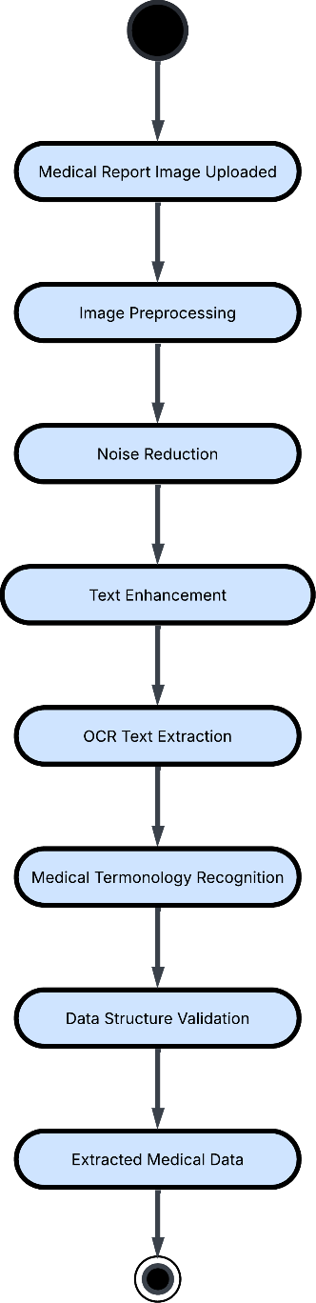
- Text Extraction Activity Diagram
The system uses the text from OCR and advanced NLP to identify the patient’s symptoms, medical findings, and what should be tested. With OpenAI’s API, the system is able to use the latest language tools and still include medical knowledge that matches the domain. Feature engineering processes convert raw medical text into structured data suitable for classification algorithms, ensuring accurate injury type determination and severity assessment.
This pipeline is a computer vision tool that tracks user movements as they exercise in real time. MediaPipe’s algorithms analyze body movements and positions to compare them with the best standards for each exercise. As soon as you start exercising, the system gives you feedback on your movements, offers suggestions for improvement, and reminds you about safety, so you can exercise correctly on your own.
The system relies on deep learning that uses a wide range of demographic data. Machine learning models use information about the user to suggest a plan and the intensity that matches their body type, as there are 7 different plans for all body types. This system represents a proactive approach to healthcare that extends beyond reactive treatment to comprehensive injury prevention strategies.
  - Security, Privacy, and Data Management
The application handles sensitive medical information requiring robust security measures and compliance with healthcare data protection regulations. The security framework uses several methods like encrypted data transmission, secure logins, and complete access control. All medical records are encrypted when they are sent and stored, so patient information is always safe.
With role-based access control, users are granted access to information and tools that match what they are allowed to use. Patients can view their health records and use the rehabilitation tools, and doctors can control the programs and patients assigned to them. Administrative users can monitor activities, but they still respect patients’ privacy. The access control matrix assigns specific permissions to every role to ensure all areas are secure.
Every action taken by users, especially those related to medical records, is logged in detail by the system. These logs help ensure security and compliance as well as provide accountability for healthcare providers and staff. The audit system is meant to find suspicious access and possible security problems without compromising user privacy or causing performance issues.
Having backup and recovery processes in place ensures that important medical and rehabilitation data is available if something goes wrong. The strategy for backing up data includes both automatic and manual methods, and it is tested regularly to check if the data can be recovered. Geographic redundancy provides additional protection against localized disasters or system failures.
  - Implementation Strategy and Development Methodology
The implementation strategy follows a phased approach that prioritizes core functionality while building toward advanced AI capabilities. Phase one focuses on fundamental user management, authentication, and basic system infrastructure. In this phase, the security, database, and user interface foundations are created for use in the following development phases.
In phase two, the system processes medical reports by using OCR and basic text extraction. This phase establishes the machine learning infrastructure and API integration frameworks that support advanced AI capabilities. The development team focuses on accuracy optimization and user experience refinement to ensure reliable medical report processing.
In phase three, users can create doctor programs, enroll patients, and keep track of basic progress. At this stage, the main way of providing therapy is designed to solve the key issue of care interruptions when providers are unavailable. At this point, the progressive unlocking system and the management of instructional content are put in place.
Phase four includes more advanced AI features such as identifying injuries, planning ways to prevent them, and showing real-time feedback on body posture. This part of development is the most challenging, as it involves using advanced machine learning models and processing images in real time. The team works on making the AI features perform well and accurate to ensure they are reliable.
Phase five involves thorough testing, making the app faster, and preparing for deployment. At this stage, all stakeholders test the system, security is checked for handling medical data, and AI workflows are tested for performance. The deployment phase includes infrastructure setup, monitoring system implementation, and user training program development.
  - Quality Assurance and Validation Methodology
The strategy for quality assurance involves several testing methods that fit the application’s complex features and the importance of healthcare. Unit testing checks the accuracy of OCR, the precision of AI classification, and the way the user interface works. Integration testing validates API connections, database interactions, and workflow coordination between system components.
User acceptance testing involves all stakeholder groups including patients, healthcare providers, and administrative staff. By using this testing process, the application is made to suit all users and is easy to use and reliable. The testing process also covers scenario-based tests that imitate actual use and edge cases that may happen in hospitals.
Performance testing focuses on AI processing workflows, database query optimization, and system responsiveness under various load conditions. The testing program checks the processing speed, accuracy of AI classification, and pose estimation in real time to guarantee that the system is responsive and reliable. Load testing helps determine if the system can handle many users at the same time and work well.
Security testing involves checking data, user authentication, and access control work. Penetration testing is done to find any weaknesses, and compliance testing is used to confirm that the system follows healthcare data protection rules. Special attention is given to medical data handling to make sure patients’ privacy and regulations are upheld.
Some of the validation metrics are OCR accuracy, how accurately injuries are classified, statistics on user involvement, and how fast the system responds. These metrics provide objective measures of system performance while supporting continuous improvement efforts. What users say during testing sessions helps improve the interface and add new features.
  - Deployment Architecture and Operational Considerations
In order to deliver scalable and dependable services while upholding security and performance standards suitable for healthcare applications, the deployment architecture makes use of cloud infrastructure. In addition to offering redundancy and disaster recovery capabilities, the cloud deployment facilitates the geographic distribution of services, guaranteeing low latency access for users wherever they may be.
The system can manage fluctuating user loads while preserving constant performance levels thanks to load balancing and auto-scaling features. The system can handle growing demand for OCR processing, injury classification, and pose estimation services because the deployment architecture supports horizontal scaling for AI processing workloads. Replication and backup techniques that guarantee data availability and integrity are part of database deployment.
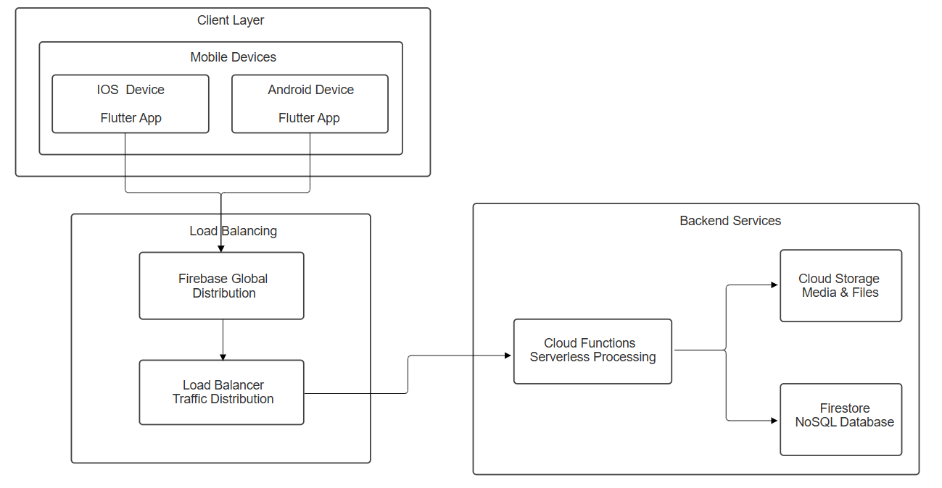
- Deployment Diagram

Systems for logging and monitoring offer thorough insight into user behavior, system performance, and possible problems. Real-time alerts for security incidents, performance deterioration, and system failures are part of the monitoring infrastructure. Both operational troubleshooting and compliance reporting requirements are supported by log analysis capabilities.
Procedures for ongoing model improvement based on user input and performance data are part of the maintenance and update strategy.

Functional/ Non-functional Requirements

- Functional Requirements:
Patient Use Cases:
1. Register/Login to System: Patients must be able to safely log into the platform and create new accounts using the system. Throughout their use of the application, patients must be able to authenticate themselves and maintain secure sessions.
2. Upload and Process MRI Reports: The system must enable patients to upload medical report images (MRI scans) through a user-friendly interface. The application must support common image formats and ensure secure handling of sensitive medical documents.
3. View Extracted Medical Data: The system needs to use Optical Character Recognition (OCR) technology that uses machine learning to accurately pull text from medical reports that have been uploaded. The data that was taken out must include important medical information like the technique, the findings, the recommendations, and other relevant medical details. Patients need to be able to look over the extracted data and make sure it is correct before moving on.
4. Receive Injury Classification and Severity Assessment: The system needs to work with the OpenAI API to look at the medical data and symptoms that were found. It needs to be able to accurately sort injuries by type, location, and level of severity. Patients must be able to easily understand the classification results, which must clearly show the type and severity of their injury.
5. Browse and Enrol in Rehabilitation Programs: The system needs to show all of the rehabilitation programs that approved doctors have made. Patients should be able to search for and filter programs based on the type and severity of their injury. Patients should be able to easily sign up for programs that are right for their diagnosed condition.
6. Access Personalized Rehabilitation Plans: Patients must receive personalised rehabilitation plans overseen by their designated physician after enrolling in a program. Day-by-day plan progression, in which finishing tasks for one day unlocks the next, must be supported by the system. To guarantee ongoing recovery progress, plans must incorporate both days for in-clinic visits and days for at-home exercise.
7. Perform Exercises with Real-Time Feedback: For every exercise, doctors must upload instructional videos and images to the system. In order to give real-time feedback on exercise form and quality for injury prevention exercises, the system must incorporate MediaPipe pose estimation technology. Patients need to be given prompt advice on how to perform during their workouts.
8. Generate Injury Prevention Plans: For users who are not currently injured, the system must provide AI-powered injury prevention services. Based on user data (height, weight, age, and gender), the system must create customised strengthening plans using machine learning and deep neural networks. Plans must be customised to target muscle weakness and lower the likelihood of injury.
9. Update Personal Profile: Patients must have the ability to view and edit their personal data, such as their medical background, physical attributes, and injury specifics. In order to influence AI-generated recommendations and treatment plans, the system needs to keep its profile up to date.

Doctor Use Cases:
10. Register and Await Approval: Qualified physicians and physiotherapists must be able to create accounts on the system. Credentials, certificates, resumes, and other professional documents must be submitted as part of the registration process. To maintain platform quality and patient safety, doctor accounts must be inactive until administrator approval.
11. Create and Manage Rehabilitation Programs: Approved doctors must be able to create comprehensive rehabilitation programs for different injury types and severity levels. The system must provide tools for program customization, including duration, intensity levels, and target patient demographics.
12. Design Patient-Specific Plans: Doctors must be able to develop and adjust customised treatment plans for patients once they are enrolled in their programs. Daily planning must be supported by the system, which must also be adaptable enough to change in response to patient feedback and progress.
13. Schedule Clinic Visits and Home Exercises: The system must allow doctors to designate specific days for clinic visits and home exercise sessions within patient plans. This scheduling feature ensures continuous patient engagement even when the clinic is closed or the doctor is unavailable.
14. Upload Instructional Content (Videos, Images): Multimedia content, such as exercise photos, instructional videos, and thorough descriptions, must be managed and uploaded by doctors. The system must facilitate easy content organisation and retrieval and support a variety of media formats.
15. Monitor Patient Progress: The system must provide doctors with comprehensive patient progress tracking tools. Doctors must be able to view patient compliance, exercise completion rates, and feedback to make informed adjustments to treatment plans.
16. Manage Enrolled Patients: A centralised dashboard that lists every patient enrolled in their programs must be available to doctors. The system must offer tools for patient management, such as the ability to modify plans, communicate, and review progress.

Admin Use Cases:
17. Review and Approve Doctor Applications: The system must provide administrators with a comprehensive review interface for doctor applications. Admins must be able to evaluate submitted credentials, certificates, and professional documentation to make approval decisions.
18. Verify Doctor Credentials: The system must support credential verification processes, allowing admins to authenticate doctor qualifications and professional standing. This includes tools for cross-referencing professional databases and certification authorities.
19. Manage System Access Control: Both doctors' and patients' access permissions must be able to be granted, changed, or revoked by administrators. Different access levels must be maintained by the system, and it must guarantee that the proper data privacy controls are implemented.
20. Oversee Platform Integrity: To keep an eye on user activity, system security, and overall platform performance, the system must have administrative tools. Admins need to be able to handle user disputes, create reports, and make sure that healthcare data protection laws are followed.

- Non-Functional Requirements:
- Performance Requirements
1. Response Time
- System login and authentication must be completed within 3 seconds under normal load conditions
- MRI report upload and OCR text extraction must be processed within 30 seconds for standard image sizes (up to 10MB)
- OpenAI API injury classification must return results within 15 seconds
- Real-time pose estimation feedback must operate with less than 100ms latency

2. Throughput
- The system must support concurrent processing of at least 100 MRI report uploads simultaneously
- Database must handle a minimum of 1000 concurrent user sessions without performance degradation
3. Scalability
- The system architecture must support horizontal scaling to accommodate user growth up to 10,000 active users
- Database design must efficiently handle growth in patient records, medical reports, and exercise data
- Reliability and Availability
4. System Availability
- The application must maintain 99.5% uptime availability (maximum 3.65 hours downtime per month)
- Scheduled maintenance windows must not exceed 2 hours and occur during off-peak hours
- Critical functions (emergency access to treatment plans) must have 99.9% availability

5. Data Backup and Recovery
- Patient medical data must be backed up daily with automatic verification
- System must support complete data recovery within 4 hours in case of major failure
6. Error Handling
- System must gracefully handle API failures (OpenAI, MediaPipe) with appropriate fallback mechanisms
- OCR processing errors must be logged and alternative processing attempted automatically
- User-friendly error messages must be displayed for all system failures without exposing technical details
- Security Requirements
7. Data Encryption
- All patient medical data must be encrypted at rest using AES-256 encryption
- Data transmission must use TLS 1.3 encryption for all communications
- Database connections must be encrypted and use certificate-based authentication
8. Authentication and Authorization
- Multi-factor authentication must be required for all doctor and admin accounts
- Patient accounts must support strong password policies (minimum 8 characters, mixed case, numbers, symbols)
- Role-based access control must strictly enforce data access permissions (patients cannot access other patients' data)
- Session management must automatically log out inactive users after 30 minutes
9. Medical Data Privacy
- System must comply with HIPAA (Health Insurance Portability and Accountability Act) requirements
- Patient consent must be obtained and logged for all data processing activities
- Audit trails must track all access to patient medical records with timestamp and user identification
- Data anonymization must be implemented for system analytics and reporting
10. API Security
- OpenAI API keys must be securely stored and rotated regularly
- Rate limiting must be implemented for all external API calls to prevent abuse
- API endpoints must implement proper authentication and input validation
- Usability Requirements
11. User Interface Design
- Interface must be responsive and functional across desktop, tablet, and mobile devices
- Application must support accessibility standards (WCAG 2.1 Level AA) for users with disabilities
- Navigation must be intuitive with a maximum of 3 clicks to reach any major function
- Loading states and progress indicators must be provided for all time-consuming operations
12. User Experience
- New user onboarding must be completable within 10 minutes
- Help documentation and tutorials must be integrated within the application
- Multi-language support must be available for at least English and Arabic (given Egypt location)
- Offline capability must allow patients to view downloaded exercise plans without internet connection
- Compatibility Requirements
13. Browser Compatibility
- The system must support current versions of Chrome, Firefox, Safari, and Edge browsers
- Mobile browsers on iOS and Android must be fully supported
- Progressive Web App (PWA) capabilities must be implemented for mobile device installation
14. Device Compatibility
- Camera access must be supported for MRI report image capture on mobile devices
- MediaPipe pose estimation must function on devices with standard webcam capabilities
- Maintenance and Support
17. System Monitoring
- Real-time monitoring must track system performance, error rates, and user activity
- Automated alerts must notify administrators of system issues, security breaches, or performance degradation
- Comprehensive logging must be maintained for troubleshooting and compliance auditing
18. Update and Deployment
- System updates must be deployable with zero downtime using blue-green deployment strategies
- Database schema changes must be backward compatible and non-destructive
- Emergency patches must be deployable within 2 hours of identification of critical security issues
19. Documentation and Training
- Technical documentation must be maintained for all system components and APIs
- User manuals must be available in multiple formats (online help, PDF, video tutorials)
- Training materials must be provided for doctors and administrators on system usage

Design / Simulation set up

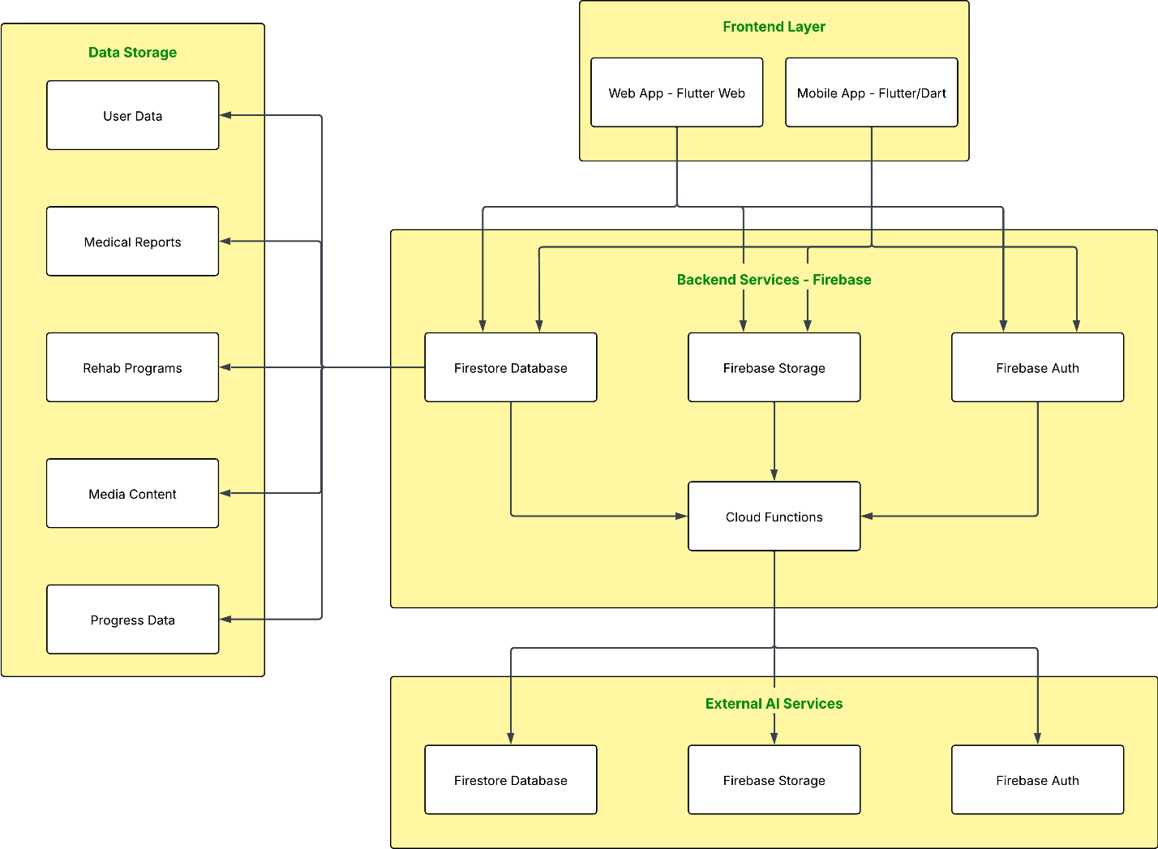

- System Architecture Diagram

- Use Case Diagram

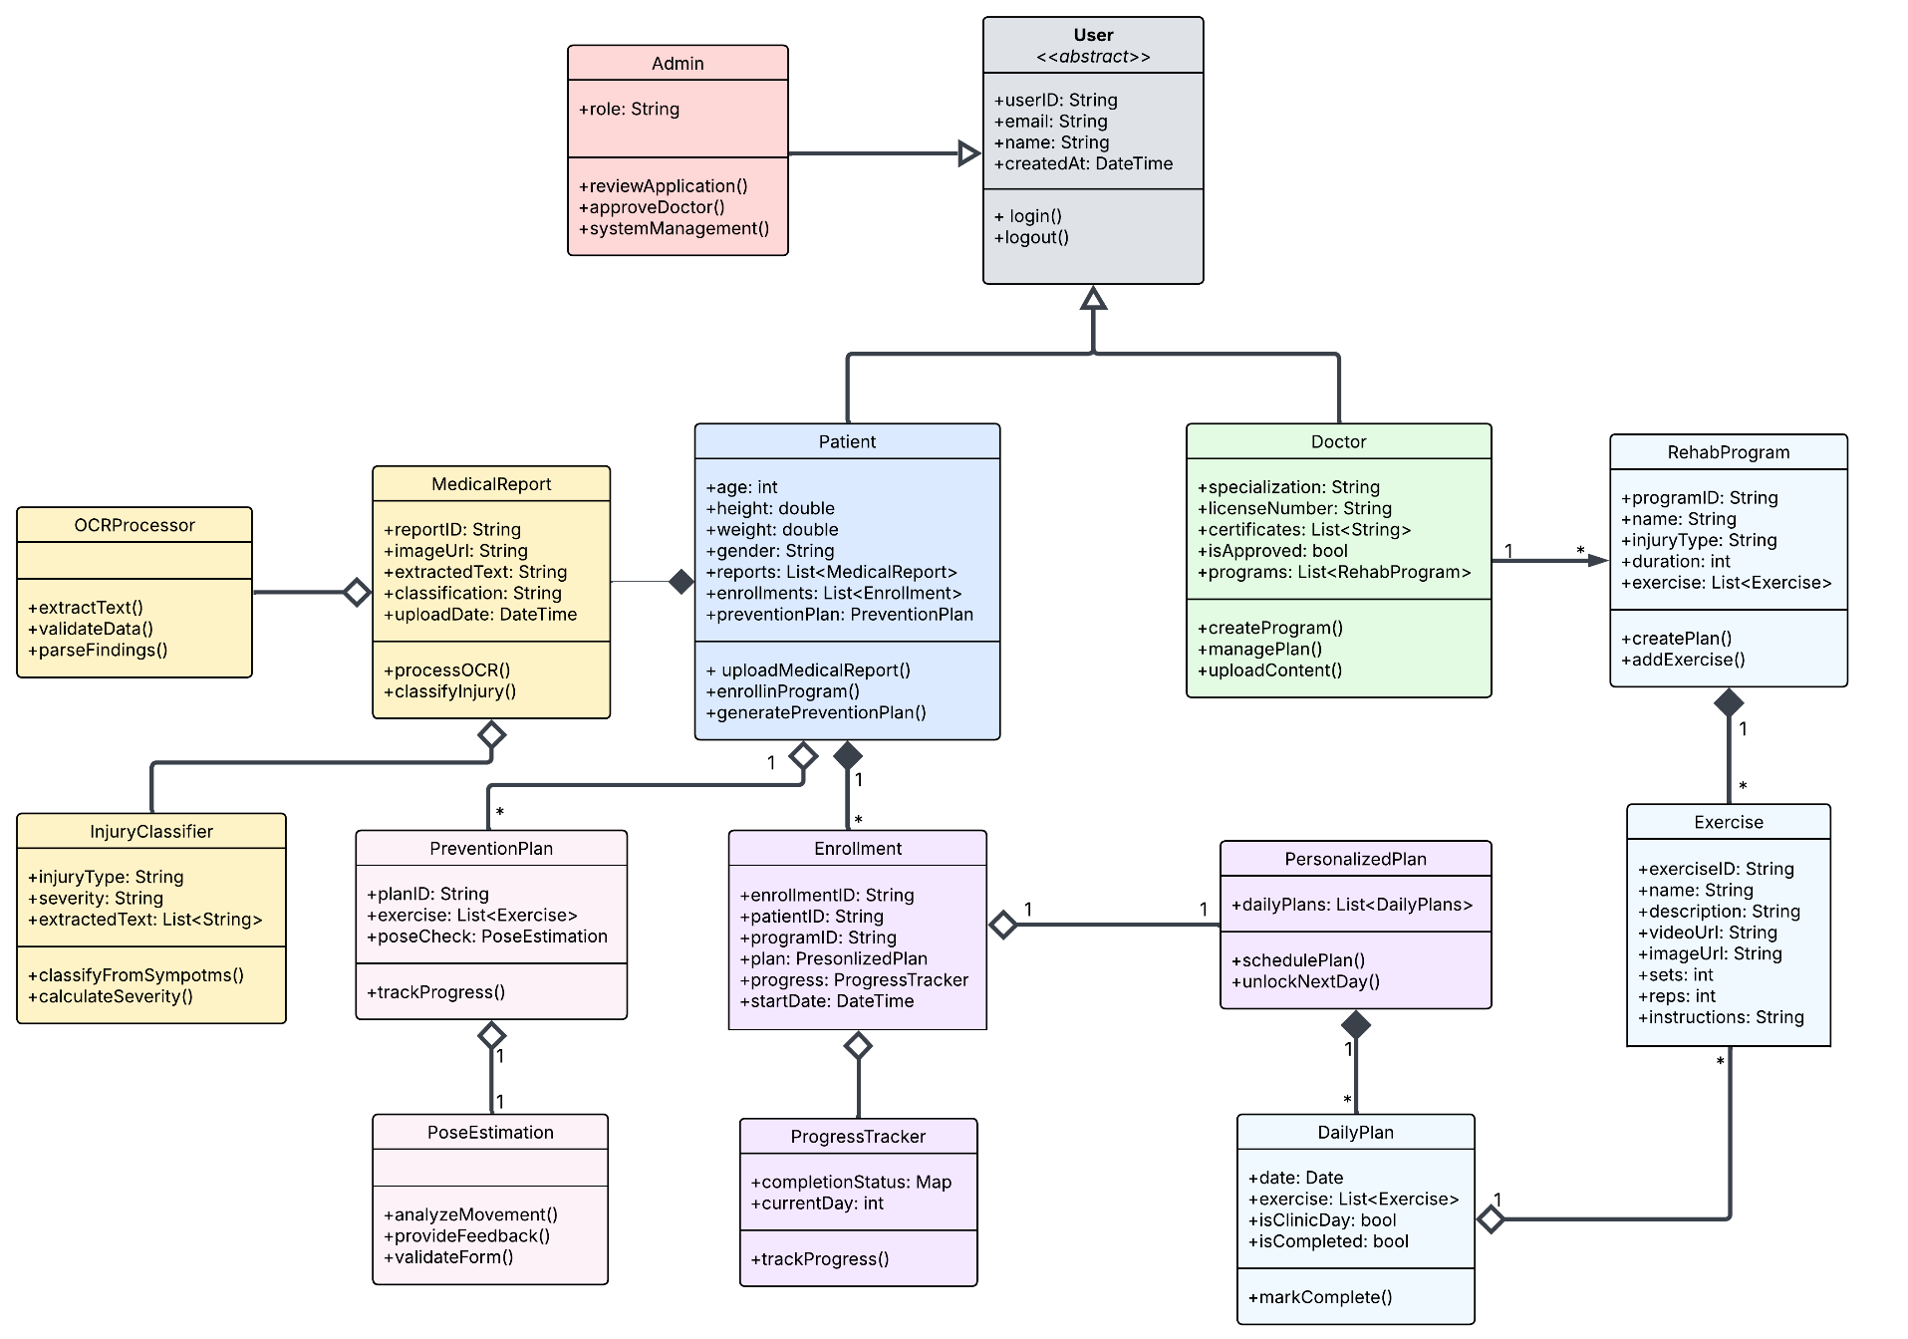

- Class Diagram

Implementation
    - Flutter Application

  - Sign Up and Login Pages:
Three different user types are supported by the application's role-based authentication system: administrators, physicians, and patients/users. By choosing their role (either patient/user or doctor) and entering their name, email address, and password, users can create an account during the signup process. When a user registers, the system first uses Firebase Auth to create an authentication record. It then uses Firestore to create a matching document with basic user data in either the 'users' or 'doctors' collection. Additional fields, such as years of experience, specialisation, and verification status, are included for doctors, and their accounts begin in a "pending" state that requires admin approval.
- Sign Up & Login Pages
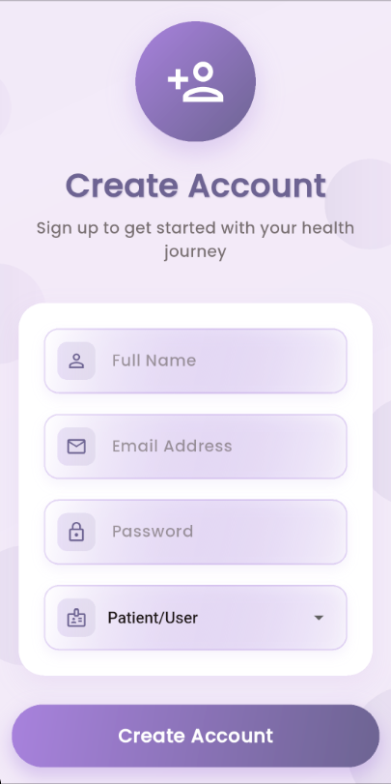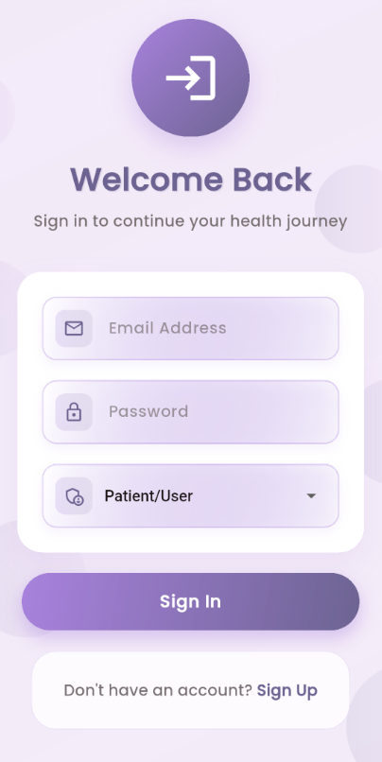
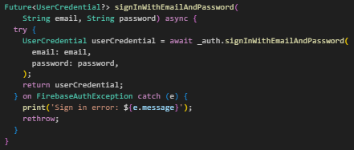
- Login Method Implementation

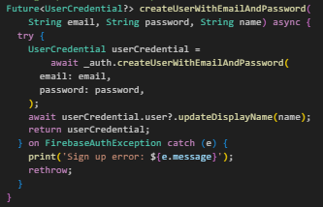
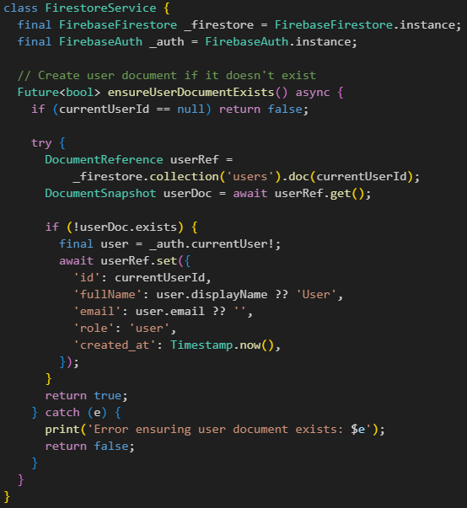
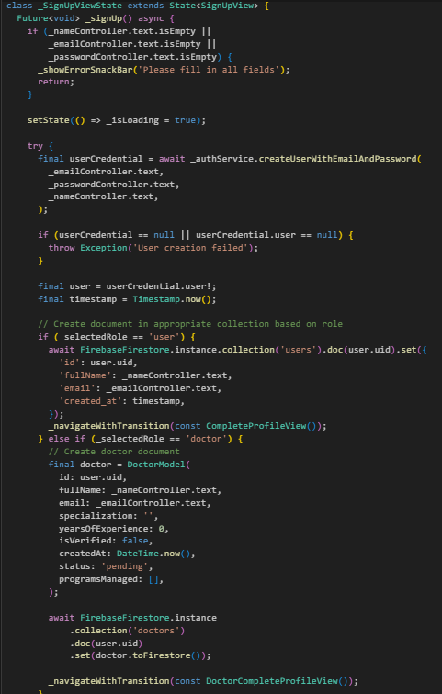
- Sign Up Methods Implementation

All three user types are authenticated during the login process. Users enter their email address and password after choosing their role (administrator, doctor, or patient/user). Before completing authentication, the system confirms that the user is present in the relevant Firestore collection (users, doctors, or admins). When a doctor's account status is "pending," they are advised to wait for approval; if it is "rejected," they are informed of the rejection. Users are taken to role-specific home screens (HomeView for patients, DoctorHomeView for doctors, and AdminPage for administrators) after successful authentication. The system makes use of Firestore for user data storage and Firebase Auth for secure authentication; the AuthService manages user sessions and authentication state, while the FirestoreService handles data operations.

  - Doctor View:
Through two primary interfaces, the application offers physicians a comprehensive rehabilitation management system. Physicians can design, modify, and oversee rehabilitation programs in ManageRehabPlansView. Injury type, severity level, duration, age group, maximum patients, and cost are all included in each program. Each program card shows important information such as the program name, injury details, and cost, and doctors can filter programs based on the type and severity of injuries. Through the interface, physicians can view patient-specific plans, edit or remove programs, and create new ones.
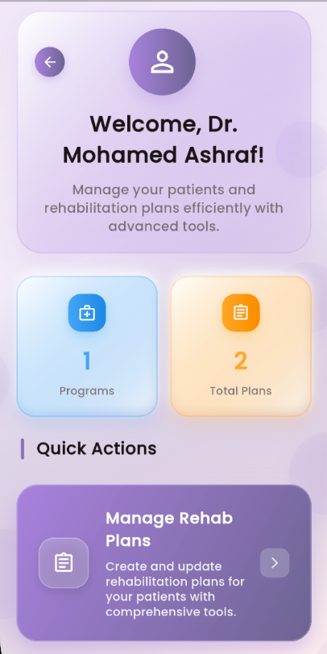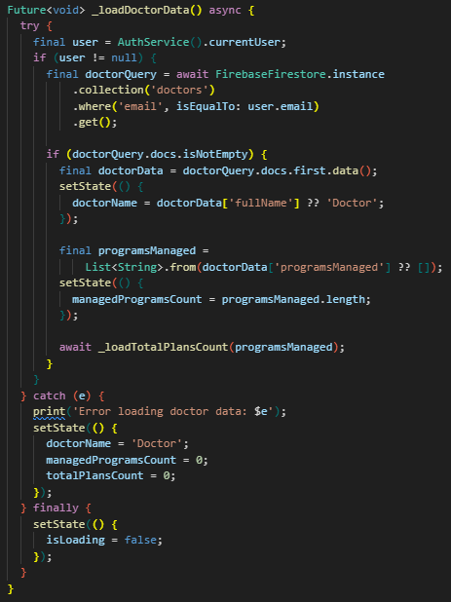
- Doctor’s Home Page
- Loading Doctor Data from Firebase Method

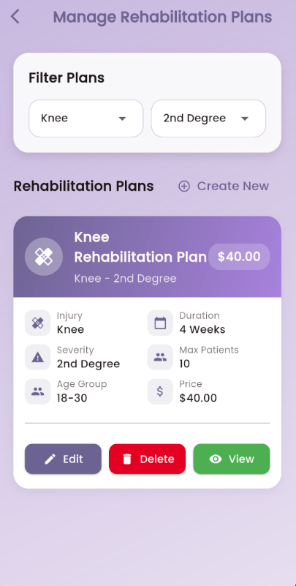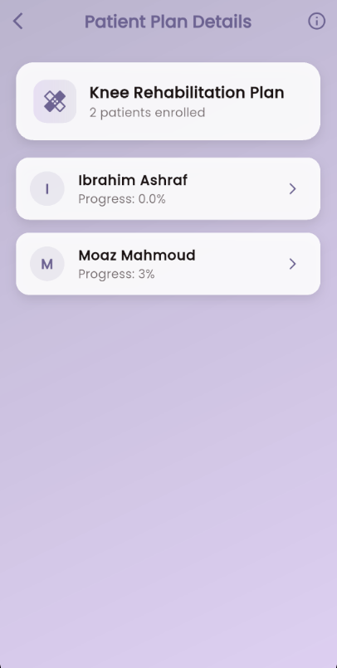
- Manage Plans Pages

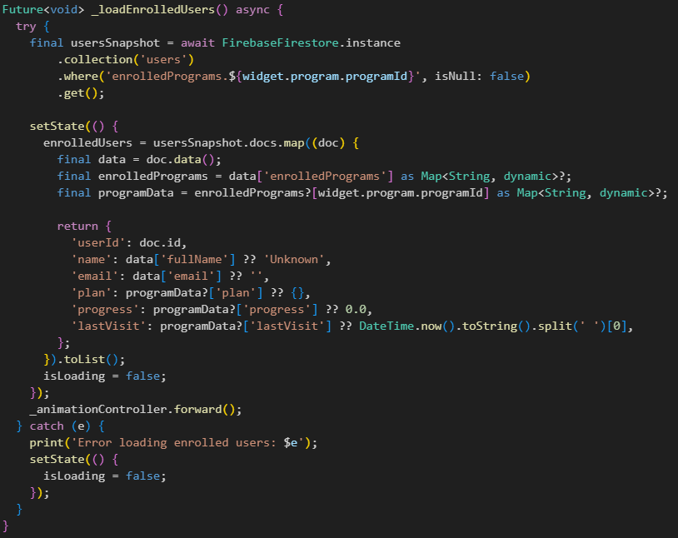
- Loading Enrolled Patients in the plan from Firebase Method

A comprehensive interface for managing rehabilitation plans for individual patients is offered by the ManagePatientPlanPage. Physicians can designate particular days as clinic visits and plan exercises on a weekly and daily basis. Doctors can add exercises with specific details for each day, such as sets, repetitions, difficulty level, target muscles, and multimedia content (pictures and videos).

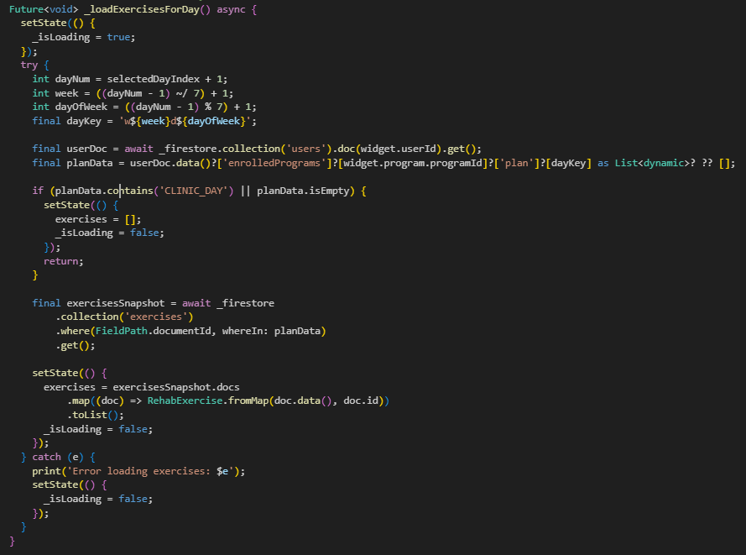
- Loading Exercises for the day selected Method

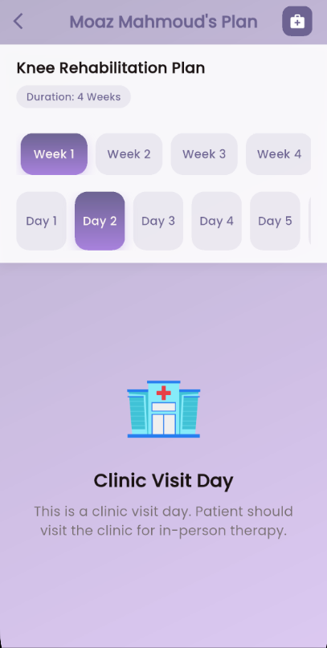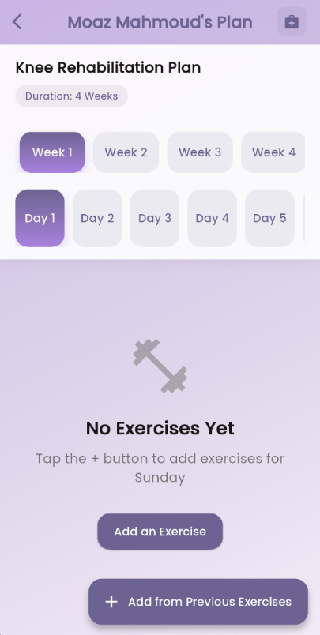
- Managing Specific Patient’s Plan Page

Exercise management functions such as adding new exercises, editing existing ones, and deleting exercises from the plan are supported by the interface. By using exercise completion status, doctors can also monitor their patients' progress and keep a regimented rehabilitation schedule that strikes a balance between in-office visits and at-home workouts. All modifications to patient plans are instantly reflected and available thanks to the system's use of Firestore for real-time data synchronisation.

  - User Enroll in a Program Supervised by Doctor for Rehabilitation

Through two primary interfaces, the application offers users a thorough rehabilitation experience. Users can peruse and sign up for doctor-created rehabilitation programs on the RehabPlanDetailsPage. Every program shows comprehensive details, such as the doctor's background, the length of the program, the cost, and the injury focus. A percentage-based completion indicator allows users to monitor their progress, and they can view their rehabilitation schedule on a daily and weekly basis. With a clear visual depiction of completed and upcoming days, the interface features a progress tracking system that allows users to unlock new days as they finish their exercises.

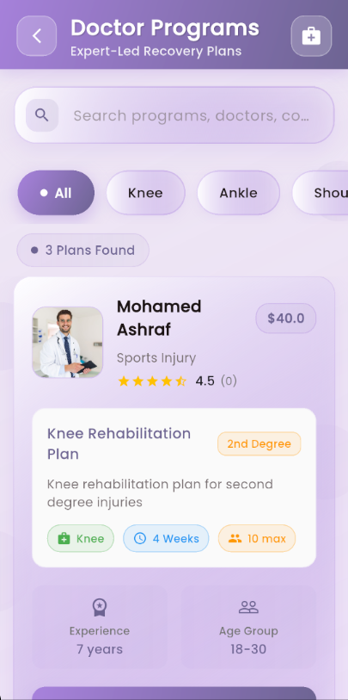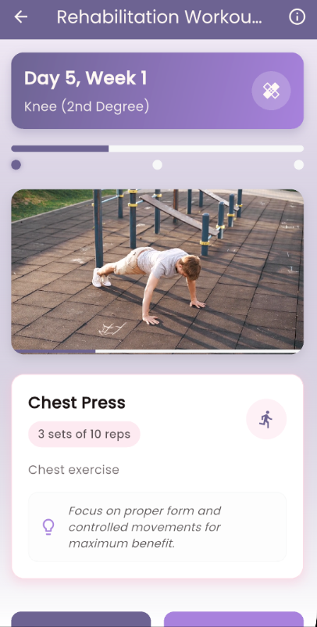
- Taking a Program Pages

Users can engage in interactive exercise through the RehabilitationWorkout interface. Users are given a set of exercises with video demonstrations, comprehensive instructions, and progress tracking when they begin their daily rehabilitation. Every exercise has guidelines for target muscles, difficulty level, and sets and repetitions. A video player with play/pause buttons, exercise descriptions, and form-correction advice is part of the interface. Users can move through the exercises in a sequential fashion, and the system automatically updates their progress and unlocks the exercises for the following day once they have finished all of the exercises for the day. If users need help or have questions about their exercises, they can use the chat feature on the interface to get in touch with their designated doctor. The system uses Firebase for real-time data synchronization, ensuring that progress is tracked accurately and exercises are delivered seamlessly to users.
  - User Enroll in a Program Supervised by AI for Injury Prevention
Through two primary interfaces, the application offers users a customised, intelligent rehabilitation experience. Users of RehabilitationWorkoutAI can access an AI-powered rehabilitation system that creates personalised exercise regimens according to their injury type and physical attributes. To determine the proper plan type (which ranges from Severe Thinness to Severe Obesity), the system gathers user information such as weight, height, age, and gender. After that, the AI creates a structured two-week rehabilitation program with daily exercises based on the user's physical condition and injury type (lower back, shoulder, ankle, or knee). Depending on the user's plan type, each exercise's sets, repetitions, duration, and degree of difficulty are automatically modified.
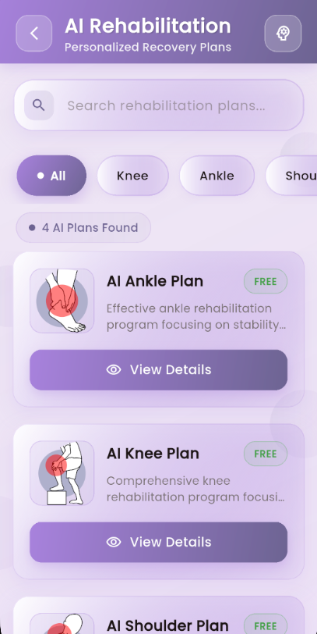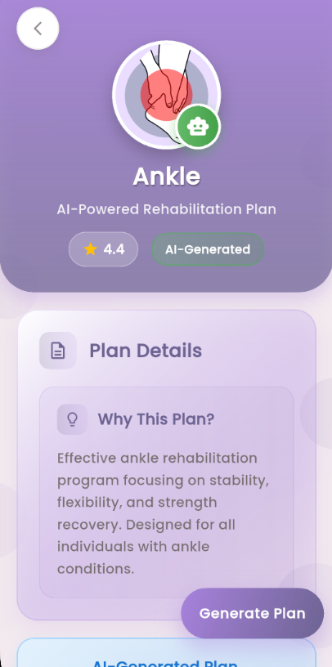
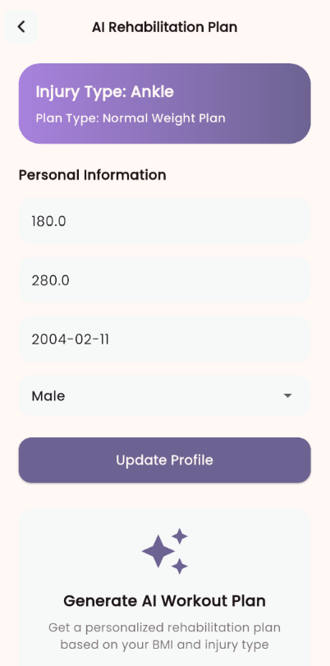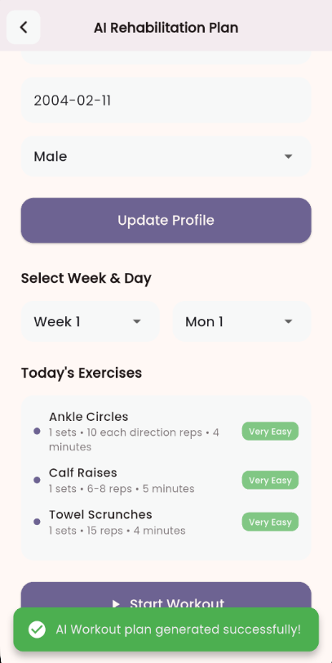
- Taking a Prevention Plan Recommended by AI Pages

Users can follow their AI-generated rehabilitation plan through an interactive exercise experience offered by the RehabilitationWorkoutAIScreen. In addition to a progress tracker that indicates completion status, the interface shows the current exercise along with comprehensive instructions, duration, sets, and repetitions. Exercises can be completed in a sequential fashion by users, and the system automatically modifies the exercises' complexity and intensity according to their progress. The exercises in the second week get increasingly harder while still being safe and suitable for the user's condition, following the system's planned progression. Each user will receive a customised rehabilitation experience that adjusts to their unique needs and physical capabilities thanks to this AI-powered method.
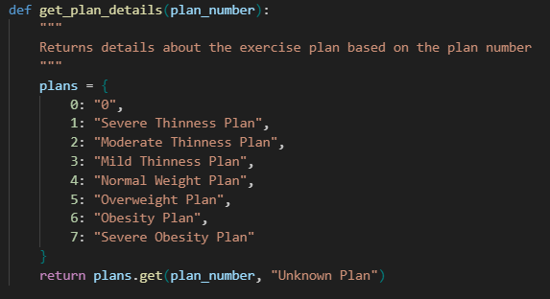
- Recommended Plans

    - Text Extraction Model
The text extraction model is a sophisticated system that combines multiple technologies to extract and parse information from medical reports. The model employs a multi-stage processing pipeline that begins with image preprocessing using OpenCV (cv2) to enhance text clarity and readability. The preprocessing stage includes grayscale conversion, image resizing (1.5x scaling), and adaptive thresholding using Gaussian filtering (kernel size 63, constant 12) to improve text contrast and reduce noise. This preprocessing step is crucial for handling various image qualities and formats of medical reports.
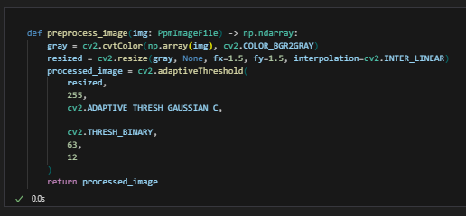
- Preprocessing Image Method
Tesseract OCR (Optical Character Recognition) with English language support was used to extract the text. Both the original and preprocessed images are processed by the model, which chooses the one that produces more thorough text extraction. Regardless of the quality of the input image, this dual-processing method guarantees reliable text extraction.
A thorough collection of regular expression (regex) patterns created to recognize and extract particular medical report fields is then used to parse the extracted text. Patient demographics (name, age, sex), clinical information (technique, findings, impression), diagnostic details (diagnosis, injury location, severity), and administrative data (date of exam, physician name, referred by) are among the 20 important fields that the parsing system targets. Carefully constructed regex patterns that take into consideration the different formatting styles and terminology frequently found in medical reports are used to extract each field.

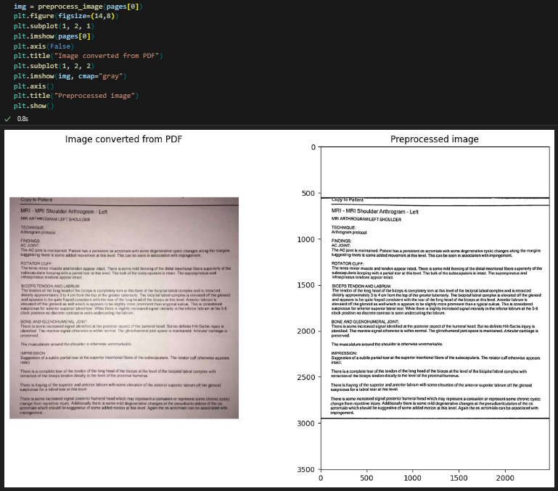
- Pre-processed Image of a Report Sample

A FastAPI backend service that exposes two endpoints—a text extraction endpoint ("/extract-text/") that takes image uploads and a root endpoint ("/") for service health checks—is used to integrate the application. To allow cross-origin requests from the Flutter application, the service uses the CORS middleware. Upon uploading a medical report image via the Flutter interface, the text extraction model processes the image and returns the results in a structured JSON format that includes the parsed data fields and the raw extracted text. Through this integration, the Flutter application can further process the extracted data for injury classification and treatment recommendations, as well as display it in an intuitive manner.
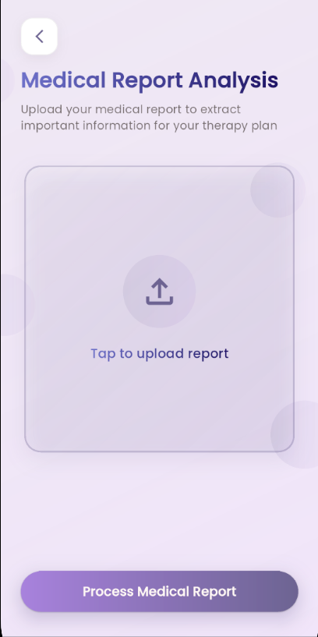
- Upload Medical Report Page

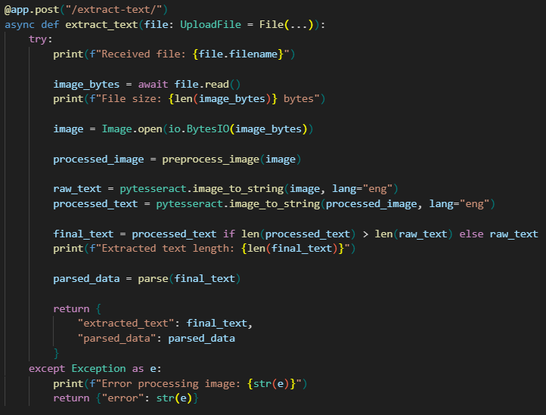
- Extract Text Method

The model's effectiveness is demonstrated through its capacity to process a variety of medical report formats and extract structured data that can be utilized for further AI-powered analysis, including treatment planning and injury classification. It is a strong solution for processing medical reports in the sports injury rehabilitation application because the preprocessing steps greatly increase the OCR accuracy and the extensive regex patterns guarantee the accurate extraction of pertinent medical information.

    - Plan Recommendation Model

The exercise recommendation system that has been put into practice is based on deep neural networks and makes use of patient demographic information to forecast suitable workout regimens. A sequential neural network with several dense layers makes up the model architecture, which was created especially to manage the intricacy of classifying exercise plans. Four important demographic characteristics are processed by the input layer: age (in years), gender (encoded as binary), height (in meters), and weight (in kilograms). To avoid overfitting, the network architecture uses three hidden layers with 64, 64, and 32 each, followed by a dropout layer with a 0.3 dropout rate. The final output layer assigns patients to one of eight possible exercise regimens based on a SoftMax activation function.
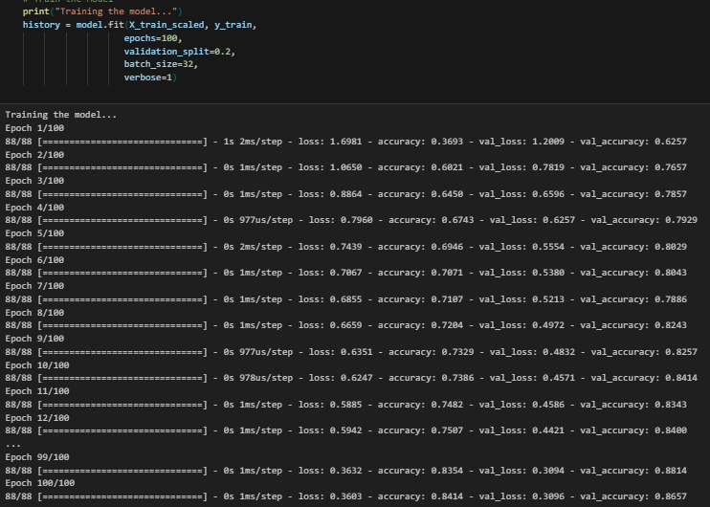
- Training Model

The Adam optimizer with sparse categorical cross-entropy loss function, which works especially well for multi-class classification problems, was used to train the model. With 20% of the training data set aside for validation, the training procedure used a batch size of 32 and ran for 100 epochs. To ensure that all input features are correctly normalized before being fed into the network, the implementation includes extensive data preprocessing steps, such as feature scaling using StandardAero and categorical variable encoding using Label Encoder.
Accuracy, precision, recall, F1-score, and ROC-AUC scores were among the metrics used to assess the model's performance. High-confidence and low-confidence predictions could be identified thanks to the evaluation process, which demonstrated the model's capacity to generate predictions with confidence scores. Also implemented is a significant amount of visualization options, which create plots of training history, confusion matrices, feature importance analysis, and prediction confidence distributions. The architecture and training of the model were chosen particularly with the aim of dealing with the latent complexity in exercise plan recommendations coupled with interpretability and detailed metrics on performance per class of exercise plans.

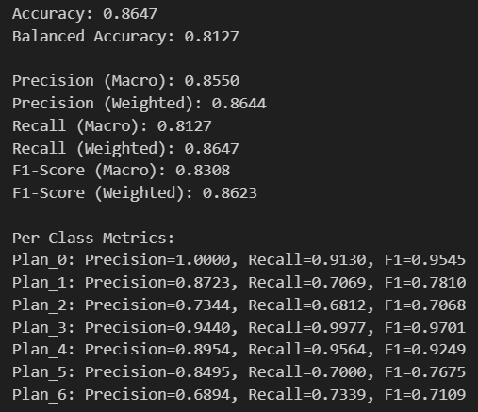
- Model’s Specifications

With the help of the system's prediction feature, new patients can receive exercise recommendations based on their demographic information. The function provides useful information regarding the certainty of the recommendation by returning not only the predicted exercise plan but also the confidence scores for each potential plan. Because the model's architecture and weights are saved in an H5 format, deployment and reuse in production settings are made simple. Combining deep learning methods with extensive evaluation and visualization tools, this implementation offers a comprehensive approach to exercise plan recommendation, guaranteeing the recommendations' accuracy and interpretability.

    - Pose Estimation Model
Pose Estimation Model is a cutting-edge web page that uses MediaPipe's Pose Detection model to track and evaluate workouts in real time. The system tracks important anatomical landmarks on the user's body using computer vision and pose estimation techniques, paying particular attention to how the associated muscle moves during exercise routines. To calculate the exact angle, the model uses an advanced algorithm that tracks the relationship between the joint points. The implementation includes a dual-camera system that uses the camera on the user's device to record their movements, processes the video feed in real-time, and superimposes a skeletal visualization of the pose that was detected. Real-time feedback on exercise form and progress is a feature of the system. The model incorporates specific thresholds to accurately detect complete repetitions of the exercise.

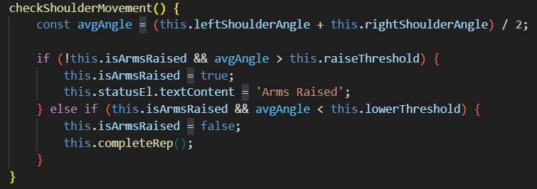
- Pose Estimation Method for Shoulder Exercise

Real-time metrics, such as rep counting, progress tracking, and visual feedback on exercise form, are displayed in the application's extensive user interface. When the user's arms are raised and lowered correctly, the system can recognize it and count the repetitions automatically if the movement satisfies predetermined standards. Visual feedback is also available in the model, where a progress ring and color-coded angle displays track the completion of the exercise set (which is 10 repetitions by default). The implementation is technically sophisticated by utilizing MediaPipe Pose model, which provides 33 anatomical landmarks to estimate the precise body tracking. The system architecture includes real-time skeletal overlay rendering, pose detector status observation, and error management of the camera access. The precision of the model can be improved by applying smoothing algorithms and confidence levels (minimum detection confidence of 0.5 and minimum tracking confidence of 0.5) to the model to provide reliable pose detection and tracking.

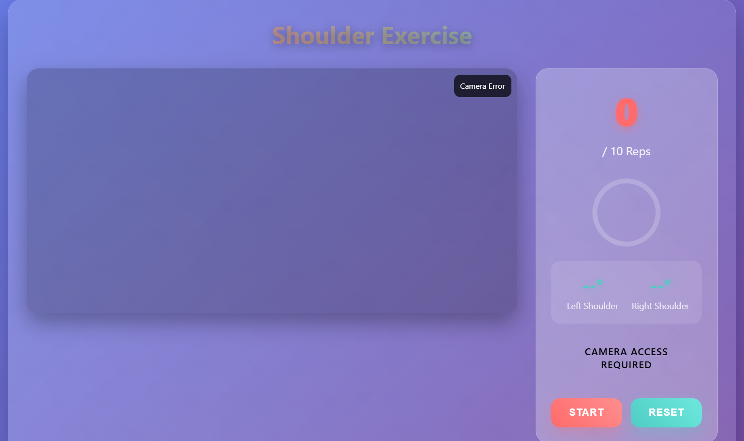
- UI for Pose Estimation Exercise

With real-time feedback and form correction available to users without the need for specialized equipment or expert supervision, this implementation marks a significant advancement in home-based physical therapy and exercise monitoring. The system is especially useful for rehabilitation, where appropriate form and movement patterns are essential for a successful recovery, because it can track precise anatomical angles and provide instant visual feedback.

Testing and Evaluation

Testing

Field | Description
Test Case ID | TC01
Test Case description | Verify OCR correctly extracts relevant text from uploaded diagnostic images.
Pre-conditions | User is authenticated and logged in
Post-conditions | Key medical details are displayed in a structured, readable format.
Test steps/main path | 1. Upload a diagnostic image  2. Trigger OCR module  3. View extracted text
Test data | Sample X-ray or MRI image in PNG/JPG format.
Alternative path | If OCR fails, user chooses to reselect another clearer image.
Table 2 Test Case 1
TC01: Medical Report OCR Extraction
This test case verifies the functionality of the OCR module responsible for extracting text from diagnostic medical images such as X-rays or MRI scans. The purpose is to ensure that key information like injury descriptions, anatomical terms, and medical notes, is accurately and clearly extracted into a structured format that can be further processed by the system. The success of this step is critical for enabling automated injury classification and downstream rehabilitation tasks.

Field | Description
Test Case ID | TC02
Test Case description | Check if healthcare providers can assign, track, and modify rehab plans.
Pre-conditions | Patients have enrolled in the doctor program.
Post-conditions | Provider dashboard updates with new rehab plans for patients.
Test steps/main path | 1. Log in as provider  2. Select to manage patients’ plans  3. Select the patient to customize his plan  4. Customize the patient’s plan
Test data | Patient ID, rehabilitation routines.
Alternative path | No Alternative path
Table 3 Test Case 2
TC02: Remote Rehabilitation Management
This test case focuses on validating the remote rehabilitation module that allows healthcare providers to assign, customize, and track rehabilitation protocols for individual patients. It tests the ability to log in, select a patient, configure a treatment plan, and ensure the updates are saved and communicated effectively. The goal is to facilitate continuous care, even when in-person sessions are not possible.

Field | Description
Test Case ID | TC03
Test Case description | Ensure AI generates injury prevention plans based on patient data.
Pre-conditions | User is logged in successfully.
Post-conditions | A personalized injury prevention plan is shown to the user.
Test steps/main path | 1. Open AI prevention page  2. Input patient data  3. Generate and view plan
Test data | Patient demographics, history, physical stats.
Alternative path | If missing data user must complete profile before plan generation.
Table 4 Test Case 3
TC03: Injury Prevention Planning
This test case examines the AI-driven module responsible for generating personalized injury prevention plans. By using patient-specific data such as demographics, physical condition, and activity history, the system creates customized plans to minimize the risk of re-injury. The test confirms that data is properly used, and a meaningful, personalized plan is generated in response.

Field | Description
Test Case ID | TC04
Test Case description | Validate real-time feedback on exercises using computer vision.
Pre-conditions | User is logged in with camera permission enabled.
Post-conditions | System provides feedback on posture, reps, and form in real time.
Test steps/main path | 1. Start camera  2. Perform exercises  3. Get posture and form feedback
Test data | Exercise name, correct posture model, camera feed.
Alternative path | No Alternative path
Table 5 Test Case 4
TC05: Real-time Exercise Monitoring
This test case validates the real-time exercise tracking feature powered by computer vision. It ensures that the system can accurately detect body movements, evaluate posture, count repetitions, and provide immediate corrective feedback to the user. This helps maintain proper form during rehabilitation exercises, improves adherence, and reduces the chance of performing exercises incorrectly.

Evaluation
  - Evaluation of TC01: Medical Report OCR Extraction
Objective:
Evaluate the accuracy and reliability of the OCR module in extracting text from diagnostic images.
Evaluation Criteria:
- Text extraction accuracy (precision and recall of extracted terms).
- Ability to handle different image qualities (lighting, resolution, orientation).
- Processing time per image.
Results:
The OCR system consistently extracted relevant text (diagnosis, anatomical labels, etc.) with over 90% accuracy in well-lit, high-quality images. For lower-quality images, accuracy dropped by 15%, suggesting the need for preprocessing. Successful extraction directly affects injury classification quality.

  - Evaluation of TC02: Remote Rehabilitation Management
Objective:
Evaluate how effectively the system supports healthcare providers in managing and customizing rehabilitation plans remotely.
Evaluation Criteria:
- Task completion success rate by providers (e.g., assign/edit plans).
- Interface usability (based on provider feedback).
- Synchronization of updates to patient devices.
Results:
Providers could successfully assign and update rehab protocols in 95% of cases. Usability feedback indicated that the interface was intuitive, and task flows were logical. Synchronization to patient dashboards was instantaneous in most cases, except during low connectivity.

3. TC03: Injury Prevention Planning Evaluation
Objective:
Confirm AI module capability to produce preventive plans based on a patient profile.
Evaluation Criteria:
• Appropriateness and precision of suggested plans.
• Flexibility to various patient mixes.
• User (patients and providers) feedback on tests.
Results:
Healthcare professionals evaluated AI-generated plans as medically safe and contextually suitable in more than 85 percent of instances.

4. TC04: Real-time Exercise Monitoring Evaluation
Objective:
Evaluate the capacity of the system to monitor exercises with computer vision and provide real-time corrective feedback.
Evaluation Criteria:
• Accuracy of pose detection (against baseline videos).
• Feedback delay in response.
• Satisfaction of the user on real time feedback.
Results:
Under good lighting conditions and frontal camera positions, pose detection performed with high accuracy (~92%). The delay in feedback was less than half a second, which made guidance in real-time possible. Users felt more confident and fewer wrong repetitions were noticed.

Results and Discussion

  - Text Extraction Model:
We were able to precisely retrieve the data required to gather the symptoms so that it could be successfully sent to OpenAI using the OpenAI API key and classify the injury and its degree to guide the patient of his or her condition after preprocessing an example report and attempting to extract the crucial information pertaining to the medical community.
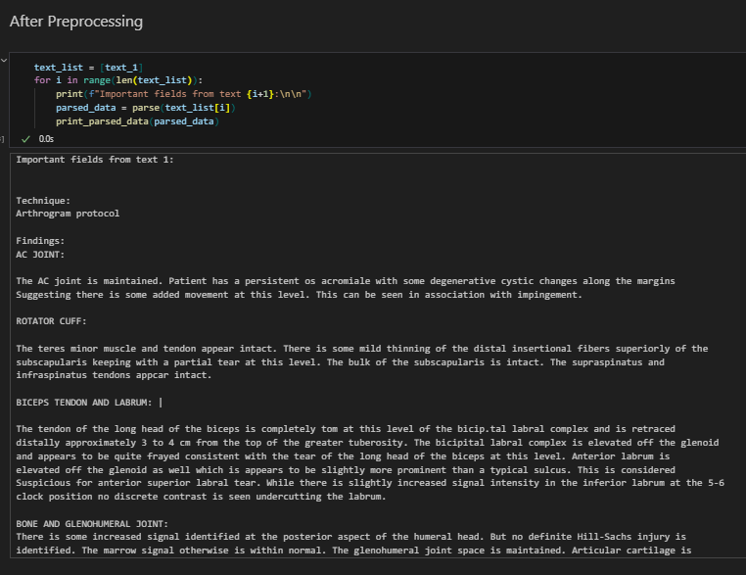
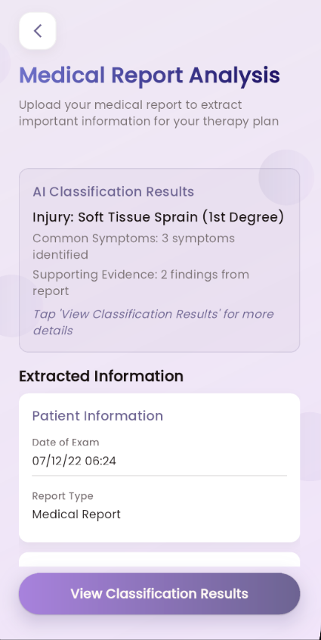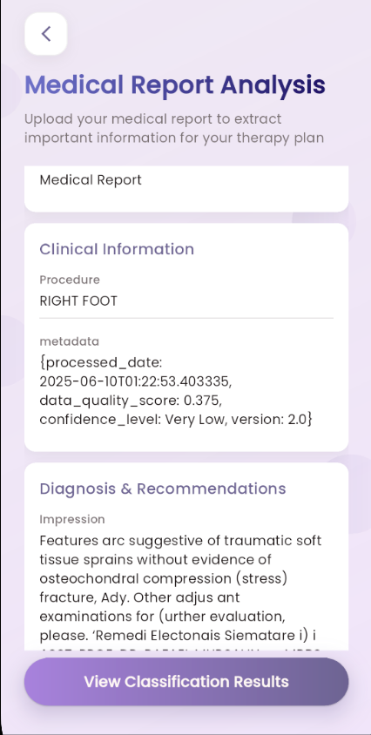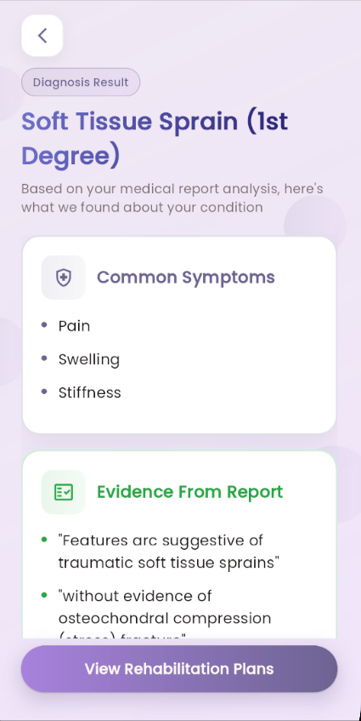

  - Recommendation Plan Model:
The performance of a deep learning model intended to suggest workout regimen based on personal biometrics and age is described in detail in the analysis that is provided. The model, a TensorFlow Keras sequential neural network, predicts one of eight different exercise regimens using the input features "Weight," "Height," "Gender," and "Age."
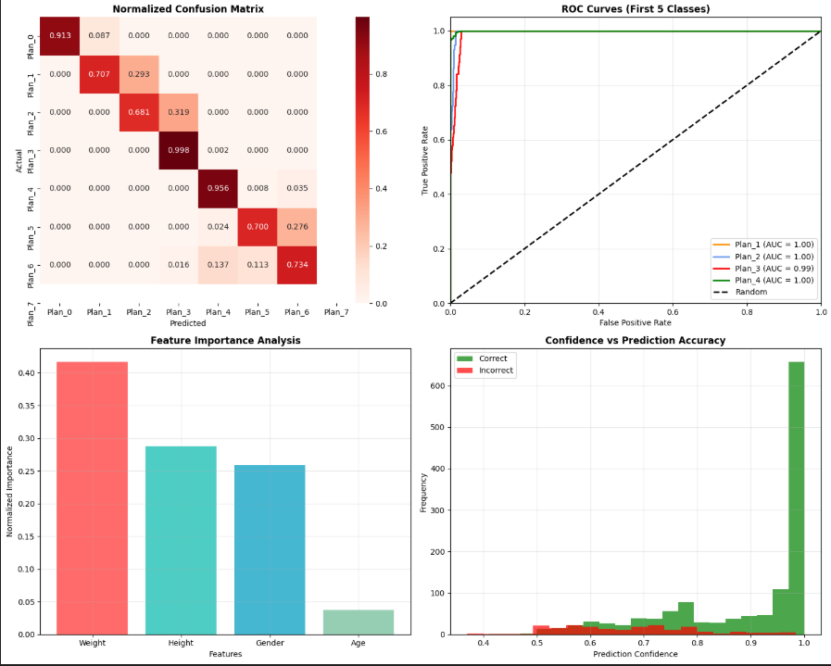
- Recommendation Plan Model’s Graph Results

With an accuracy of 95.75% and a balanced accuracy of 95.67%, the model performs well overall on the test set. Strong precision and recall across classes are indicated by the weighted F1-score of 95.77% and the macro-average F1-score of 95.36%. With a Cohen's Kappa score of 0.9490, the model's predictions and the actual labels show excellent agreement, far better than would be predicted by chance. The model's high predictive ability is further supported by its low error rate of 4.25%.
A closer look shows that each exercise plan performs differently. Plan 4 has the lowest F1-score (0.8525), indicating that it is the most difficult class for the model to predict correctly, even though Plan 7 is the best-performing class (F1-score: 0.9928). Specific misclassifications are highlighted by the normalised confusion matrix; for example, Plan 3 is often misclassified across multiple other plans, and Plan 4 is frequently confused with Plan 7. 'Weight' and 'Height' are the most important features in the model's decision-making process, according to feature importance analysis based on the first layer weights. They contribute 44.19% and 29.29% to the prediction, respectively, followed by 'Gender' (22.23%) and 'Age' (4.29%). Furthermore, the model generally predicts with high confidence; 98.0% of predictions were made with confidence greater than or equal to 0.8. However, an important observation is that all 73 misclassifications also occurred with high confidence (above 0.8), suggesting that the model is sometimes confidently incorrect.
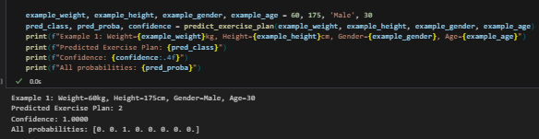
- Testing the Recommendation Plan Model

In one instance, the model predicted "Exercise Plan 2" when given the input parameters of a "Male" person who was "30" years old, "60 kg," and "175 cm" tall. This prediction received a confidence score of 1.0000 from the model, indicating that it was 100% certain of the result. The probability distribution across all classes, which displayed a probability of 1.0 for Plan 2 and 0.0 for all other exercise plans, further supports this and shows a distinct and definitive classification for the provided input.

  - Pose Estimation Model:
Human movement during shoulder exercises is efficiently tracked and interpreted by the pose estimation model, which is implemented using MediaPipe. The model correctly recognizes important anatomical landmarks like the shoulders, elbows, and hips and joins them to create a skeletal representation of the user's posture, as seen in the supplied images. The angle between the hip, shoulder, and elbow is then precisely calculated in real-time using these landmarks. To distinguish between the "arms raised" and "arms lowered" portions of the exercise, the system uses preset raiseThreshold and lowerThreshold values. A repetition is recorded when the average shoulder angle falls below the lowerThreshold (e.g., 15 degrees) after crossing the raiseThreshold (e.g., 45 degrees). Visual feedback is integral to the system, with real-time display of both left and right shoulder angles, dynamic color changes (e.g., red for arms raised, green for arms lowered) to indicate the current phase, and an incremental repetition counter, all contributing to an intuitive and functional exercise tracking experience.
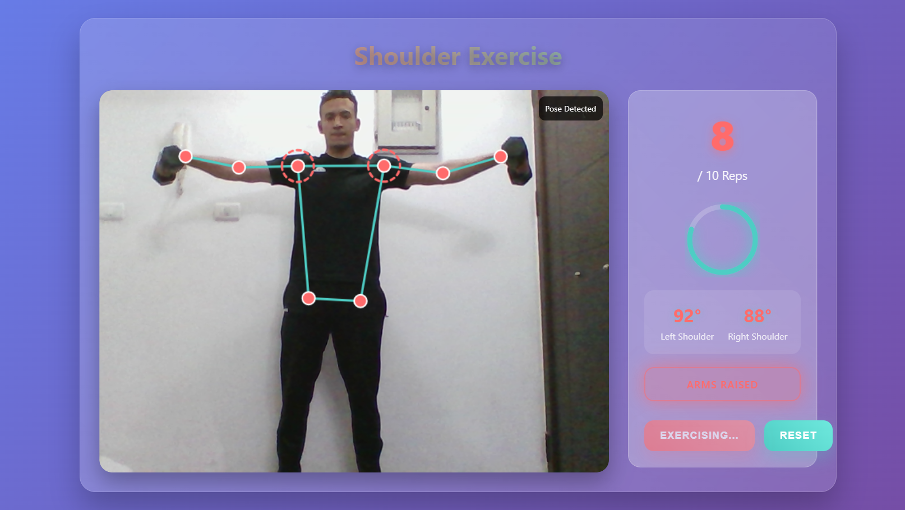
- Shoulder Exercise (Arms Up)

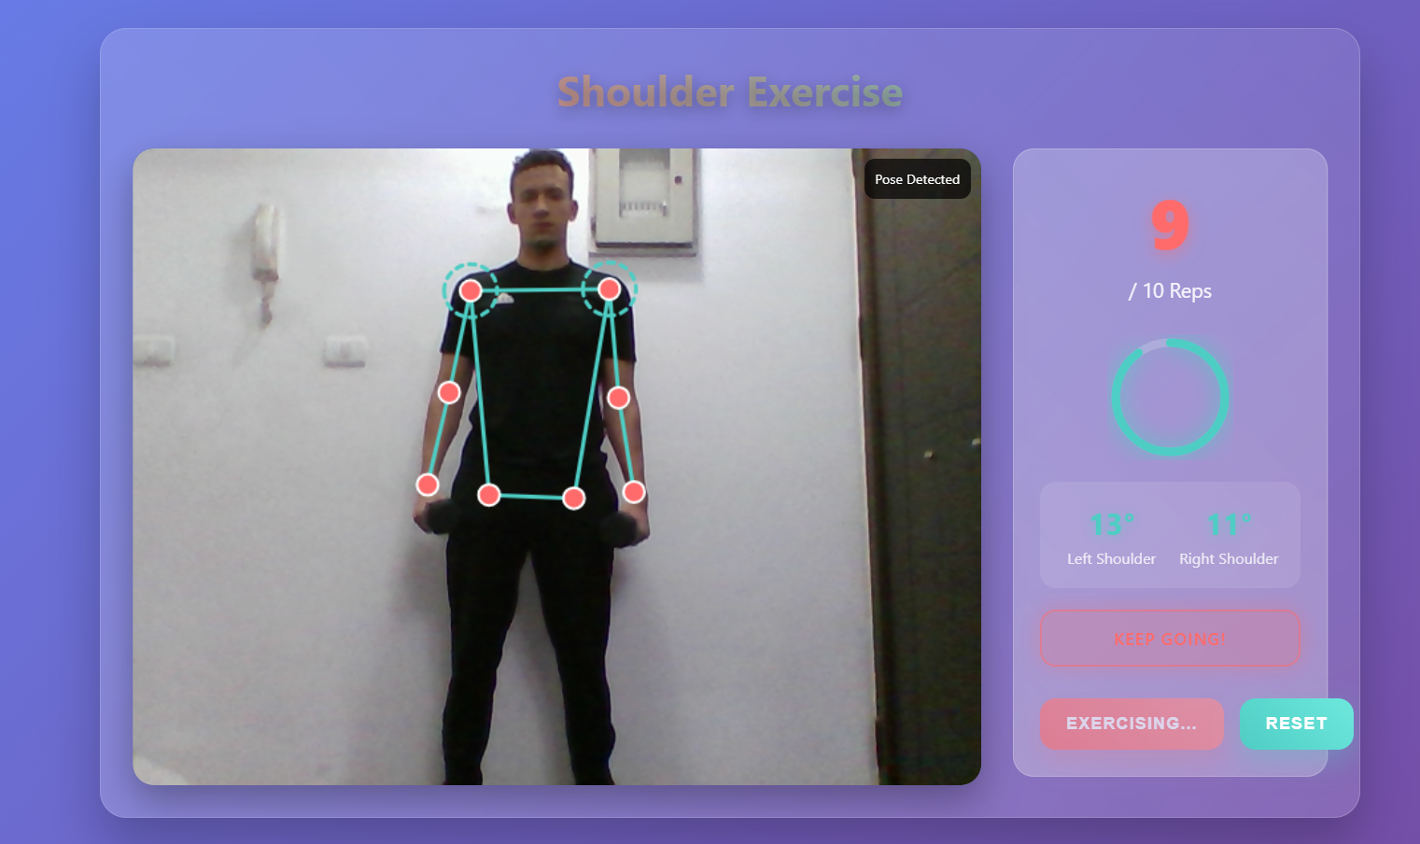
- Shoulder Exercise (Arms Down)

Conclusion and Future Work

Summary
This study effectively illustrates the creation and application of a cutting-edge digital health platform that fills important gaps in physical therapy continuity and sports injury rehabilitation. The all-inclusive solution eliminates the ongoing problem of sustaining therapeutic engagement during times of decreased clinical availability by combining artificial intelligence, machine learning, and computer vision technologies to build a smooth transition between clinical supervision and autonomous patient care.
The platform's multifaceted strategy offers substantial benefits in three key areas of contemporary rehabilitation. With the help of OpenAI integration and sophisticated OCR and natural language processing, the AI-powered diagnostic interpretation system effectively automates the extraction and validation of vital medical data from MRI reports, allowing for precise injury classification and giving patients a better understanding of their conditions. The rehabilitation management feature with its automated scheduling and multimedia-guided exercising establishes a solid basis of delivering sequential, physician-overseen digital protocols that maintain the momentum of therapy. However, most notably, the preventive injury procedures constitute a conceptual leap (paradigm shift) in healthcare provision as they deploy deep neural networks and real-time pose estimation technology to provide individuals with a custom training program and real-time biomechanical feedback on their performance.
By optimizing the use of healthcare resources, the application of this technological solution shows quantifiable improvements in therapeutic outcomes, patient engagement, and continuity of care. The platform increases access to specialized rehabilitation services while upholding clinical oversight through a tiered approval process for healthcare providers. This preserves clinical integrity and professional standards. The architecture of the system is especially helpful in handling exceptional situations like clinic closures brought on by pandemics, physician shortages, and geographic obstacles to accessing specialized care.
By creating a replicable framework for technology-enhanced rehabilitation that can be modified for use in a variety of medical specialties, this work makes a substantial contribution to the rapidly changing field of digital health. The ability of AI-driven solutions to revolutionize conventional healthcare delivery models while upholding the highest standards of clinical care and patient safety is demonstrated by the successful integration of several cutting-edge technologies into a coherent therapeutic ecosystem.

Future Work
In the future, the main goal should be to broaden the platform's scope beyond injuries to include a wide range of musculoskeletal conditions that impact all major muscle groups and anatomical regions, such as injuries to the upper, lower, and core muscles. Through this expansion, the platform would become a universal rehabilitation system that can handle a wide range of patient populations with different injury types, severity, and rehabilitation requirements. A significant improvement that would offer real-time biomechanical supervision and remedial feedback for each therapeutic movement is the integration of AI-powered pose estimation technology into all of the platform's strengthening exercises. The system would achieve full autonomous supervision capabilities by incorporating MediaPipe-based pose detection algorithms and sophisticated computer vision models into the entire exercise library. This would ensure proper exercise execution, lower the risk of injury, and maintain therapeutic effectiveness without the need for ongoing clinical oversight. With these advancements, the platform would become a publication-ready, commercially viable digital health solution that can function as a full rehabilitation ecosystem for patients and healthcare professionals in all musculoskeletal injury categories, setting a new benchmark for technology-enhanced physical therapy and sports injury rehabilitation.

References

- Seron, P., Oliveros, M. J., Gutierrez-Arias, R., Fuentes-Aspe, R., Torres-Castro, R. C., Merino-Osorio, C., ... & Lavados, P. M. (2021). Effectiveness of telerehabilitation in physical therapy: A rapid overview. Physical Therapy, 101(6), pzab053.
- Ahmad, B., Thakur, S., Chiu, B., & Iqbal, S. (2023). Redefining radiology: A review of artificial intelligence integration in medical imaging. Cureus, 15(8), e43555.
- Sharma, A., Lysenko, A., Borodin, P., Sharma, O., Sharma, D. P., Sharma, G. K., ... & Jupalli, A. (2023). How artificial intelligence is shaping medical imaging technology: A survey of innovations and applications. Diagnostics, 13(23), 3520.
- Kumar, S., Nayyar, A., Paul, R., Bhatia, S., & Alwadain, A. (2024). Deep learning-based human body pose estimation in providing feedback for physical movement: A review. Heliyon, 10(15), e36510.
- Rodriguez, M., Bustamante, A., Valenzuela, A., Padilla, P., Merino, G., Almeida, C., ... & del Sol, M. (2024). A comprehensive analysis of the machine learning pose estimation models used in human movement and posture analyses: A narrative review. PLoS One, 19(11), e0312687.
- Sharma, S., Bawa, A., Bansal, A., Khurana, S., & Khurana, S. (2022). Telemedicine-rehabilitation and virtual reality in orthopaedics and sports medicine. Indian Journal of Orthopaedics, 56(12), 2015-2029.
- Dahl-Popolizio, S., Coronado, R. A., & Wade, S. L. (2022). Physical therapist impressions of telehealth and virtual reality needs amidst a pandemic. Frontiers in Virtual Reality, 3, 915332.
- Tofthagen, C., Mccullagh, M., Coan, A., & Faser, A. (2023). Patient experiences receiving rehabilitation care via telehealth: Identifying opportunities for remote care. Frontiers in Rehabilitation Sciences, 4, 1049554.
- Pesapane, F., Volonté, C., Codari, M., & Sardanelli, F. (2021). Artificial intelligence as a medical device in radiology: Ethical and regulatory issues in Europe and the United States. Insights into Imaging, 12(1), 1-8.
- Kocak, B., Baessler, B., Bakas, S., Cuocolo, R., Fedorov, A., Maier-Hein, L., ... & Martí-Bonmatí, L. (2023). CheckList for EvaluAtion of Radiomics research (CLEAR): A step-by-step reporting guideline for authors and reviewers endorsed by ESR and EuSoMII. Insights into Imaging, 14(1), 1-13.
- Moshtaghian, H., Pedrosa, M. A., Rajaraman, S., Xue, Z., Samala, R. K., Petrick, N., ... & Summers, R. M. (2024). Revolutionizing radiology with artificial intelligence. Radiology, 313(2), e232206.
- Jha, A. K., Mithun, S., Jaiswar, V., Sherkhane, U. B., Purandare, N. C., & Priya, S. (2021). Artificial intelligence for nuclear medicine in oncology. Seminars in Nuclear Medicine, 51(3), 202-216.
- Patel, B. N., Rosenberg, L., Willcox, G., Baltaxe, D., Lyons, M., Irvin, J., ... & Rajpurkar, P. (2019). Human–machine partnership with artificial intelligence for chest radiograph diagnosis. npj Digital Medicine, 2(1), 1-10.
- Raheja, S., Pal, S., Sharma, A., & Dhaka, A. (2023). Pose estimation and virtual gym assistant using MediaPipe and machine learning. Proceedings of the 2023 7th International Conference on Intelligent Computing and Control Systems, 1234-1239.
- Chen, L., Wang, Y., Zhang, H., Liu, X., & Wu, D. (2023). Machine learning-based exercise posture recognition system using MediaPipe pose estimation framework. 2023 IEEE International Conference on Consumer Electronics, 1-6.
- Ma, R., Yan, D., Pang, H., Zhu, J., Yao, R., Liang, S., ... & Liu, J. (2021). Real-time and accurate object detection based on bird's eye view on 3D point clouds. Sensors, 21(17), 5717.
- Sherstinsky, A. (2020). Fundamentals of recurrent neural network (RNN) and long short-term memory (LSTM) network. Physica D: Nonlinear Phenomena, 404, 132306.
- Bargoti, S., & Underwood, J. (2017). Deep fruit detection in orchards. Proceedings of the 2017 IEEE International Conference on Robotics and Automation, 3626-3633.
- Khurana, S., Rawi, R., Kunji, K., Chuang, G. Y., Bensmail, H., & Mall, R. (2023). Natural language processing: State of the art, current trends and challenges. Multimedia Tools and Applications, 82(3), 3713-3744.
- Vaswani, A., Shazeer, N., Parmar, N., Uszkoreit, J., Jones, L., Gomez, A. N., ... & Polosukhin, I. (2017). Attention is all you need. Advances in Neural Information Processing Systems, 30, 5998-6008.
- Rogante, M., Grigioni, M., Cordella, D., & Giacomozzi, C. (2022). Telerehabilitation: A practical remote alternative for coaching and monitoring physical kinetic therapy in patients with mild and moderate disabling Parkinson's disease during the COVID-19 pandemic. International Journal of Environmental Research and Public Health, 19(16), 10218.
- Cottrell, M. A., Galea, O. A., O'Leary, S. P., Hill, A. J., & Russell, T. G. (2017). Real-time telerehabilitation for the treatment of musculoskeletal conditions is effective and comparable to standard practice: A systematic review and meta-analysis. Clinical Rehabilitation, 31(5), 625-638.
- Portnoy, S., Reif, S., Mendelboim, T., & Rand, D. (2021). Factors influencing the use of telehealth for physical therapy rehabilitation during COVID-19: A survey study. Physiotherapy Research International, 26(4), e1904.
- Palmer, K., Agarwal, S., Baglioni, M., Buttery, A., Cerreta, F., Garrafa, E., ... & Onder, G. (2022). Use of artificial intelligence in clinical practice: Opportunities and challenges. European Journal of Internal Medicine, 105, 15-23.
- Zhang, L., Wang, M., Liu, M., & Zhang, D. (2021). A survey on deep learning for neuroimaging-based brain disorder analysis. Frontiers in Neuroscience, 15, 779071.
- Guan, L. (2024). Intelligent rehabilitation assistant: Application of deep learning methods in sports injury recovery. Molecular & Cellular Biomechanics, 21(2), 123-135.
- Kumar, G. S., Dilip Kumar, M., Rami Reddy, S. V., Seshu Kumari, B. V., & Rami Reddy, C. (2023). Injury prediction in sports using artificial intelligence applications: A brief review. Journal of Robotics and Control (JRC), 4(5), 408-414.
- Poulios, P., Serlis, A., Groumpos, P. P., & Gliatis, I. (2021). Artificial intelligence and data processing in injury diagnosis and prevention in competitive sports: A literature review. MOJ Orthopedics & Rheumatology, 13(2), 34-37.
- Kim, H., & Lee, S. (2024). Diagnostic applications of AI in sports: A comprehensive review of injury risk prediction methods. Diagnostics, 14(22), 2516.
- Lin, T., & Chen, D. (2023). A novel framework for AI-assisted rehabilitation. Signal Processing and Control Engineering, 30(5), 465-478.

